# Chapter 3

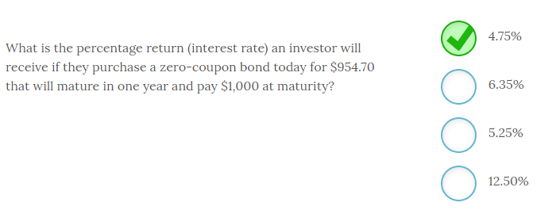

The percentage return (interest rate) an investor will receive if they purchase a zero-coupon bond today for $954.70 that will mature in one year and pay $1,000 at maturity is **4.75%**.

Given the time value of money, we know that the $1,000 we expect to receive in the future (FV) has a value today (PV) of $954.70. Since we know that the holding period is only one year, you can easily calculate that rate with your financial calculator using the following key strokes:

PV = -954.70; FV = $1,000; N=1; PMT = 0; CPT I/Y and you will get 4.75%

In addition, you know that the rate will be somewhere close to 5% since the $45.30/$954.70 is slightly less than 5%. For one year periods, you can use this simple method to approximate the rate. The other interest rate choices above are arbitrary.

In later modules, you will discover this calculation is known as the yield to maturity or YTM. It is also the same process, we will use to calculate an internal rate of return (IRR).

-------------------------------------------------------------------------------------------------------------------------------------------------------------------------------------------------------------

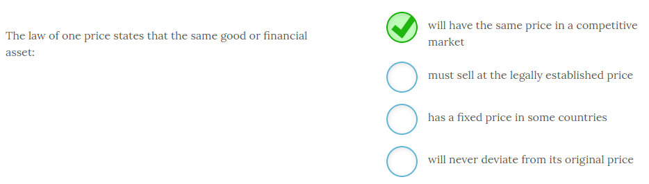

The law of one price states that the same good or financial asset **will have the same price in a competitive market**.

The reason this is true is not because the law requires this condition to hold, or that a country fixes a specific price, but that the act of arbitrage will keep prices equal. If the selling price is higher than the buying price an arbitrager will simultaneously buy and sell the asset, which moves the prices back to the same level. In competitive markets, these price discrepancies will be very short lived.

-------------------------------------------------------------------------------------------------------------------------------------------------------------------------------------------------------------

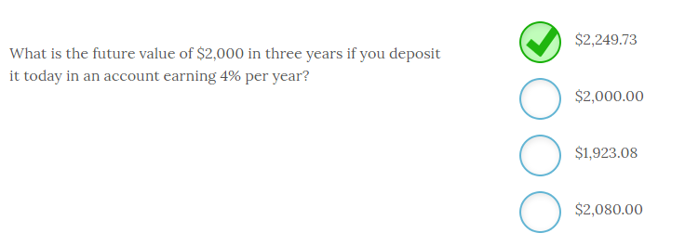

The future value of $2,000 in three years if you deposit it today in an account earning 4% per year is **$2,249.73**.

You can calculate this using the formula FV = PV(1 + i)n where, i = interest rate and n = number of periods. Therefore, FV = $2,000(1 + .04)3 = $2,249.73. The future value will always exceed the present value for any interest rate above zero. The $2,000 lump sum will be worth $2,080 in one year assuming a 4% return.

-------------------------------------------------------------------------------------------------------------------------------------------------------------------------------------------------------------

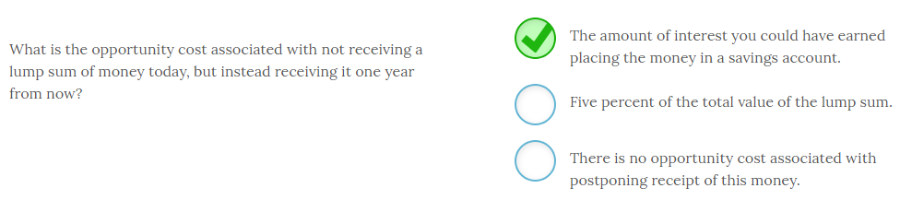

The opportunity cost associated with not receiving a lump sum of money today, but instead receiving it one year from now is equivalent to **the amount of interest you could have earned placing the money in a savings account**.

The opportunity cost is the cost associated with the next best option. In this case, you could have received the money today and earned some rate of return. That foregone return is the opportunity cost. Since the lost income depends on the market rate of interest at the time, we have no way of knowing whether it is 5% or not. As long as the market rate exceeds zero, holding all else constant, there will be an opportunity cost associated with postponing receipt of this cash flow.

The lost opportunity for investing these funds is one of the primary reasons there is a time value of money. Another potential opportunity cost is the cost associated with the loss of purchasing power due to inflation. If you received the money today, you could spend it and buy more goods and services with that amount than you would be able to buy with that amount in one year, assuming an inflation rate greater than zero.

-------------------------------------------------------------------------------------------------------------------------------------------------------------------------------------------------------------

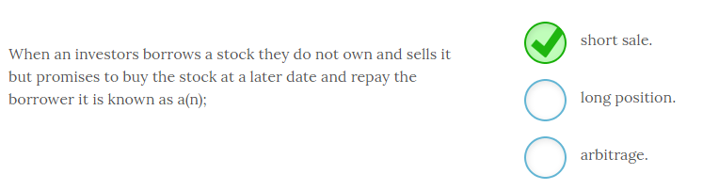

When an investor borrows a stock they do not own and sells it with a promise to buy the stock at a later date and repay the borrower it is known as a **short sale**. Investors who believe a stock will fall in value may short the stock (i.e. borrow it and sell it) and buy the stock after it falls in value. The investor will profit based on the difference between the selling price and the buying price minus any transaction costs.

An investor has a long position when they buy a stock to sell at some later date. Arbitrage occurs when you buy and sell simultaneously and therefore incur no risk.

-------------------------------------------------------------------------------------------------------------------------------------------------------------------------------------------------------------

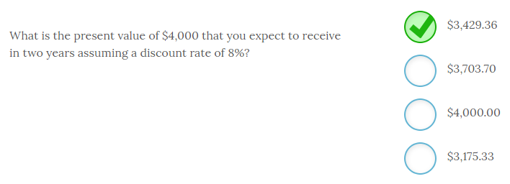

The present value of $4,000 that you expect to receive in two years assuming a discount rate of 8% is equal to **$3,429.36**.

The present value would be $3,703.70 if you expected to receive the cash flow at the end of one year and $3,175.33 if you expected to receive the $4,000 at the end of three years. The easy method to make the calculation is to use a financial calculator and input the following keystrokes:

FV = -$4,000; N = 2; I/Y = 8%; CPT PV

-------------------------------------------------------------------------------------------------------------------------------------------------------------------------------------------------------------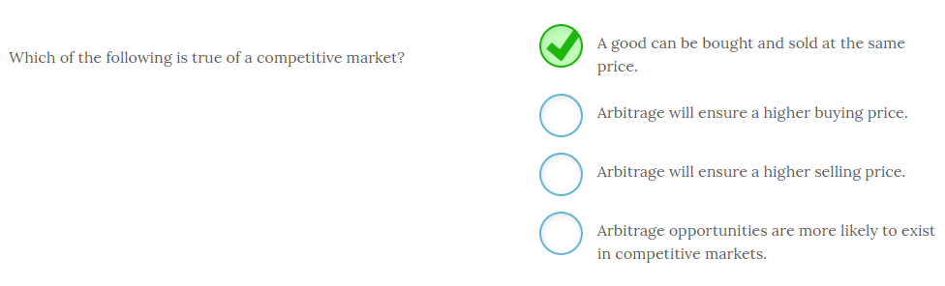

In a competitive market, **a good can be bought and sold at the same price**.

The valuation principle in finance ensures that there is only one price for a product in a competitive market. Arbitrage will eliminate any deviations from one price as soon as it is identified. If you can buy at a lower price and sell at a higher price, there will be an increase in demand that pushes the buy price higher and an increase in supply at the higher selling price that pushes it lower until a new equilibrium price is established. The quest for profits by arbitragers will cause the prices to converge instantly. So, in a pure competitive market arbitrage opportunities will be rapidly eliminated and the buy and sell price will be one price.

Arbitragers buy low and sell high to make a profit and quickly eliminate any price differential through this activity. For it to be true arbitrage, the buying and selling must happen simultaneously. If the asset is held for a period of time, it is not a riskless transaction and becomes investing or speculation.

-------------------------------------------------------------------------------------------------------------------------------------------------------------------------------------------------------------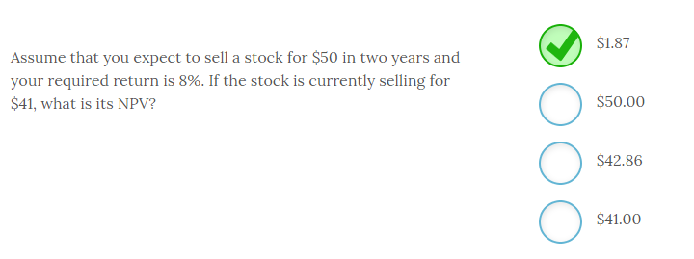

Assume that you expect to sell a stock for $50 in two years and your required return is 8%. If the stock is currently selling for $41, the NPV is **$1.87**.

The only expected cash flow in this example is the forecasted selling price of the stock which is $50. So, the NPV is equal to the present value of the expected cash flows minus the current price which is: NPV = [$50/(1.08)2] - $41 = $42.87 - $41 = $1.87.

Keep in mind that if these cash flows were certain and the market was competitive, the stock should have an NPV = 0. However, forecasting future selling prices or cash flows is not an exact science.

-------------------------------------------------------------------------------------------------------------------------------------------------------------------------------------------------------------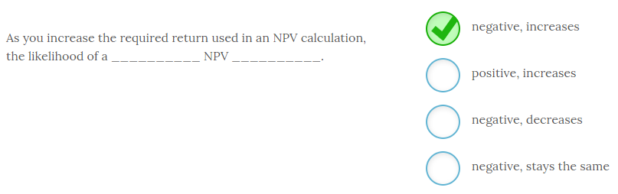

As you increase the required return used in an NPV calculation, the likelihood of a **negative** NPV **increases**.

Increasing the required return decreases the present value of the cash flows. This, in turn, decreases the NPV which increases the chance that the NPV will be negative. Higher discount rates always reduce the present value of the cash flows.

The discount rate used in the NPV calculation should be commensurate with the level of risk of the project. That way a higher risk project has a lower likelihood of being accepted, all things equal.

-------------------------------------------------------------------------------------------------------------------------------------------------------------------------------------------------------------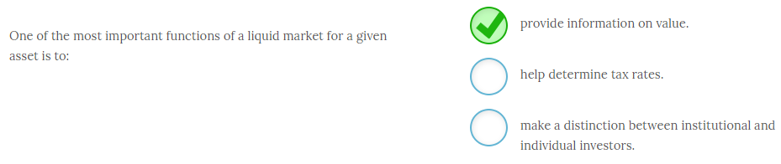

One of the most important functions of a liquid market for a given asset is to **provide information on value.** Competitive markets need a large number of buyers and sellers in order to provide sufficient liquidity. When markets are liquid they provide a clear signal of the value of an asset that thinly traded or illiquid markets cannot provide. Competitive liquid markets are therefore critical since the goal of the firm is to maximize shareholder wealth and the stock price is the metric managers monitor to see if they are achieving their goal.

Governments, not markets, determine tax rates. Institutional investors and individual investors both benefit from liquid markets but there is no distinction made between these investor types.

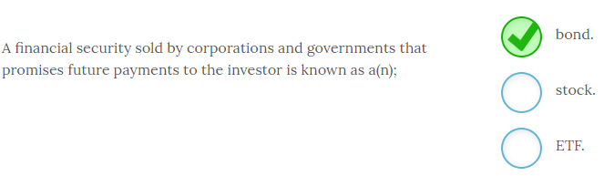

A financial security sold by corporations and governments that promises future payments to the investor is known as a **bond**. Bonds are essentially IOUs that promise to pay investors the face value of the bond at some future date. In most cases they also pay investors annual or semiannual interest payments.

Stocks and ETF (exchange traded funds) make no promise of repayment and are also not issued by governments.

Some bonds, known as zero coupon bonds or zeros, pay no interest and are simply sold at a discount.

-------------------------------------------------------------------------------------------------------------------------------------------------------------------------------------------------------------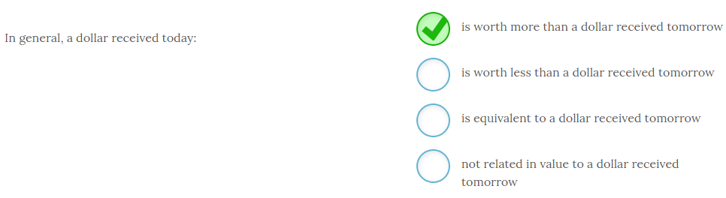

In general, a dollar received today **is worth more than a dollar received tomorrow**.

As long as there is a positive interest rate, you can invest money you have today and it will increase in value. Because of the opportunity cost of this foregone interest earned, you would place a higher value on receiving the dollar today instead of tomorrow or next year. This difference in value over time is known as the time value of money.

This concept should be intuitive to you. Most of you would prefer to receive $100 today instead of $100 in one year. Why? Because of the time value of money. Even if you did not invest it, but instead wanted to spend the money, you would prefer it now since inflation would reduce the purchasing power of the $100 you expect to receive in one year. You would rather get it today and spend it or invest it because money has a time value.

-------------------------------------------------------------------------------------------------------------------------------------------------------------------------------------------------------------

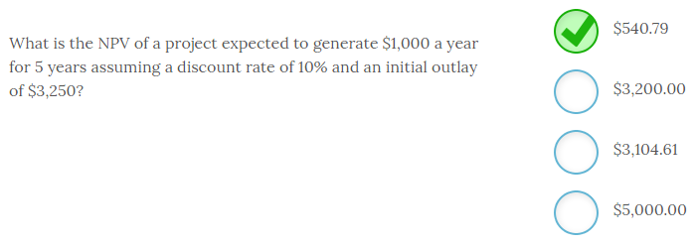

The NPV of a project expected to generate $1,000 a year for 5 years assuming a discount rate of 10% and an initial outlay of $3,250 is **$540.79**.

The easiest way to solve this problem is to use a financial calculator with the following inputs:

PMT = -$1,000; N = 5; I / Y = 10%; CPT PV. PV is equal to $3,790.79 - $3,250 = $540.79. Since the NPV is positive, the project should be accepted.

Remember that when NPV = 0 the project generated a return that was exactly equal to the required return.

-------------------------------------------------------------------------------------------------------------------------------------------------------------------------------------------------------------

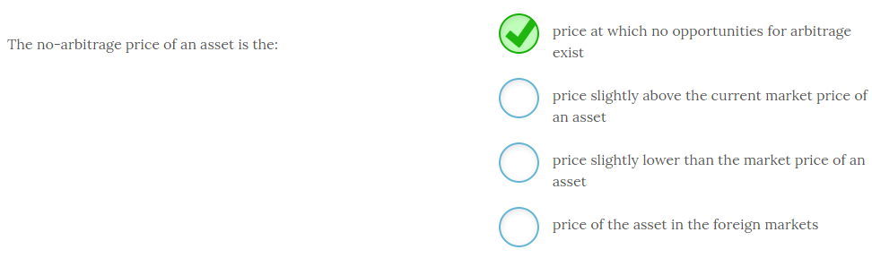

The no-arbitrage price of an asset is the **price at which no opportunities for arbitrage exist**.

At any asset price above or below the current market price, there would be an opportunity to simultaneously buy and sell the asset to make a profit. Only when the price is exactly at the point where no arbitrage profits exist is the asset priced at the no-arbitrage price. Foreign markets may present arbitrage opportunities depending on their level of competitiveness.

In a competitive market, the no-arbitrage price will be the prevailing market price.

-------------------------------------------------------------------------------------------------------------------------------------------------------------------------------------------------------------

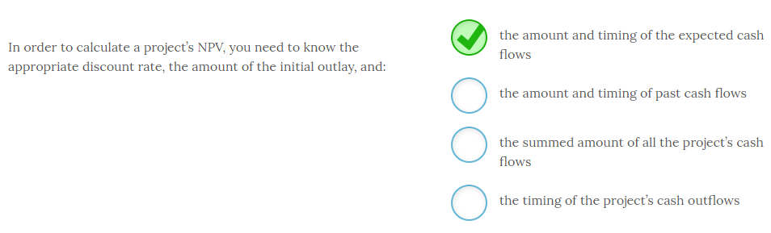

In order to calculate a project’s NPV, you need to know the appropriate discount rate, the amount of the initial outlay, and **the amount and timing of the expected cash flows**.

To calculate an NPV, you need to calculate the present value of the project’s expected cash flows. In order to make that calculation, you need to forecast the amount and timing of these cash flows. The next step is to subtract the initial outlay from this amount and see if the result is positive or negative. If the NPV is positive, you should accept the project since it generates your required return at a minimum.

Past cash flows are irrelevant since the NPV should be based on future cash flows. The timing of when these cash flows will occur is critical to the present value as well, so summing the cash flows is incorrect since you will lose the timing in that process. And, you need the timing of all cash flows, not just outflows.

-------------------------------------------------------------------------------------------------------------------------------------------------------------------------------------------------------------

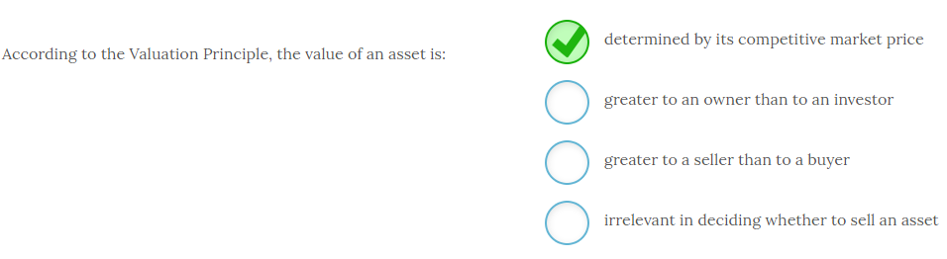

According to the Valuation Principle, the value of an asset is **determined by its competitive market price**.

Anyone conducting cost vs. benefit analysis should use the competitively determined market price. If the benefits are greater than the costs, then an asset should be acquired. As it relates to the firm, this action will increase shareholder wealth.

The only asset value that is relevant is the one determined by the competitive market, and this price is the same to the buyer and the seller. This is the price that should be used for decision making purposes.

The Valuation Principle is an application of the marginal cost vs. marginal benefit analysis you learned about in economics. The decision rule is still the same. If the benefits are greater than the costs, it is a good decision. In this case, good decisions add value to the firm in the form of increased shareholder wealth.

-------------------------------------------------------------------------------------------------------------------------------------------------------------------------------------------------------------

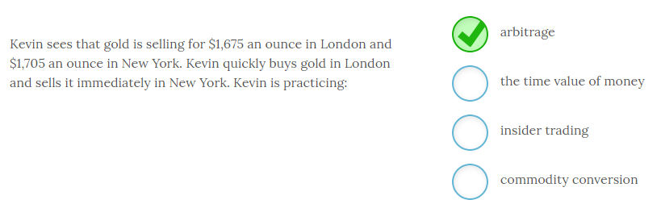

Kevin sees that gold is selling for $1,675 an ounce in London and $1,705 an ounce in New York. Kevin quickly buys gold in London and sells it immediately in New York. Kevin is practicing **arbitrage**.

Arbitrage is the immediate buying and selling of some asset where the arbitrager finds a price discrepancy. Since this activity occurs instantaneously, the time value of money is not a factor. Kevin is also not an insider and is trading with publicly available information. No commodities are converted in this practice.

This practice will cause the price to converge in both markets and the opportunity to profit from this transaction will rapidly disappear as enough buyers and sellers take advantage of it and the prices become equivalent.

-------------------------------------------------------------------------------------------------------------------------------------------------------------------------------------------------------------

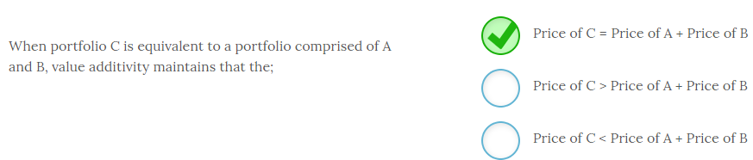

When portfolio C is equivalent to a portfolio comprised of A and B, value additivity maintains that **Price of C = Price of A + Price of B**. The law of one price states that value is neither created nor destroyed by simply combining two assets into one portfolio. The value of the portfolio is still the present value of all future cash flows which has not changed. If the value differed then investors would arbitrage the profits away until the equality held.

-------------------------------------------------------------------------------------------------------------------------------------------------------------------------------------------------------------

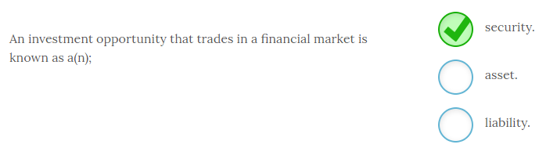

An investment opportunity that trades in a financial market is known as a **security**, or financial security. Stocks, bonds, futures, mutual funds and other derivative securities are all examples of financial assets.

Financial securities are assets but there are many assets that are not financial securities and do not trade in financial markets.

-------------------------------------------------------------------------------------------------------------------------------------------------------------------------------------------------------------

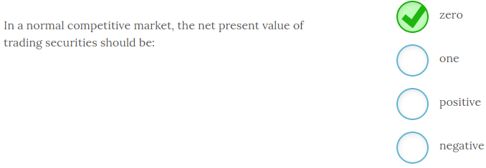

In a normal competitive market, the net present value of trading securities should be **zero**.

If buying a stock or bond presented a positive NPV, then investors would jump on that opportunity and push the price higher until the NPV was zero. So, any deviation from an NPV of zero will not last long due to arbitrage.

-------------------------------------------------------------------------------------------------------------------------------------------------------------------------------------------------------------

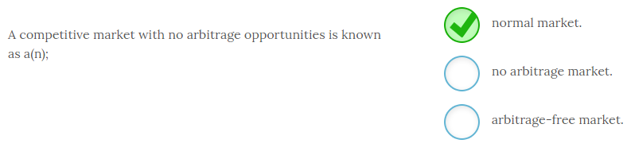

A competitive market with no arbitrage opportunities is known as a **normal market**. Most markets with a number of participants are normal markets since arbitrage opportunities are acted on rapidly and therefore disappear almost as soon as they appear. A market with arbitrage opportunities is therefore not the norm.

-------------------------------------------------------------------------------------------------------------------------------------------------------------------------------------------------------------

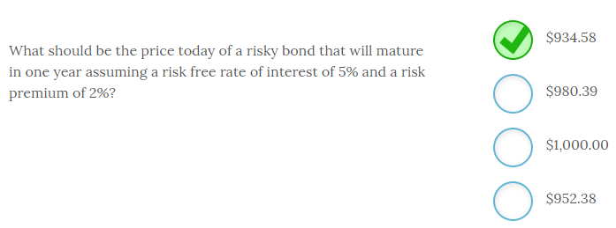

The price today of a risky bond that will mature in one year assuming a risk free rate of interest of 5% and a risk premium of 2% should be **$934.58**.

Since risky bonds do not pay interest, the value is merely the present value of the $1,000 cash flow you expect to receive in one year discounted back to the present using an interest rate commensurate with the bond’s risk. Since this bond is a risky bond, you need to use a discount rate of 7%, which is the sum of the risk free rate of 5% and the 2% risk premium. So, $1,000/1.07 = $934.58.

The risk free bond would be priced at $952.30 or $1,000/1.05. The bond would be priced at $1,000 assuming a zero percent discount rate and $980.39 if the interest rate was 2%.

-------------------------------------------------------------------------------------------------------------------------------------------------------------------------------------------------------------

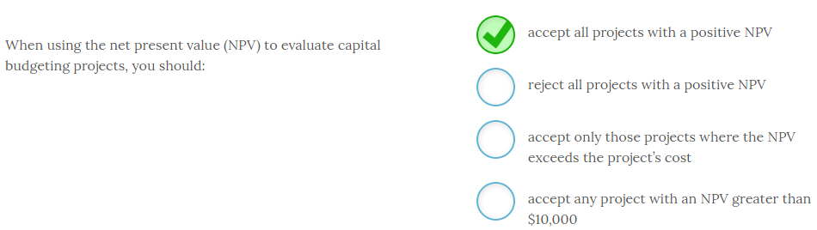

When using the net present value (NPV) to evaluate capital budgeting projects, you should **accept all projects with a positive NPV**.

NPV calculates the present value of the project’s expected cash flows and then subtracts the initial project cost or initial outlay. To calculate the present values, you should use a discount rate equivalent to the return you demand for that project. Therefore, when NPV = 0, you are earning exactly your required return. Any positive NPV means you are earning your required return plus some additional premium. For this reason, the decision rule for NPV is to accept all projects that have positive NPVs.

NPV is the best project evaluation tool to use in capital budgeting. It will always give the correct accept or reject decision given your cash flow projections. However, keep in mind that whether the decision is ultimately good or bad depends on the accuracy of the cash flow projections. In most cases, you will not know the answer to that until the life of the project is completed or well underway.

-------------------------------------------------------------------------------------------------------------------------------------------------------------------------------------------------------------

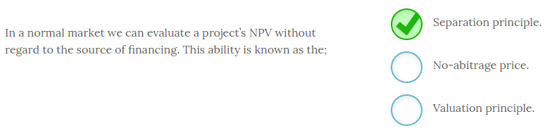

In a normal market we can evaluate a project’s NPV without regard to the source of financing. This ability is known as the **Separation principle**. In other words we can separate the financing and investment decision. This ability is due to the fact that the cost of financing is already factored into the discount rate used to compute the NPV.

The no-arbitrage price is the price of an asset in a normal market with no arbitrage opportunities.

-------------------------------------------------------------------------------------------------------------------------------------------------------------------------------------------------------------

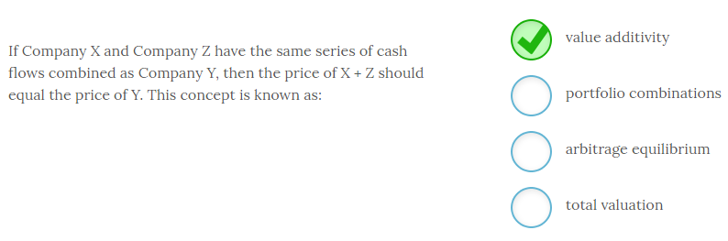

If Company X and Company Z have the same series of cash flows combined as Company Y, then the price of X + Z should equal the price of Y. This concept is known as **value additivity**.

Since Y has the same cash flows as X + Z, the value of Y has to be equal to the value of X + Z in a competitive market assuming the same level of risk. If these prices were out of balance, then an opportunity for arbitrage would exist. If prices are consistent with value additivity, then it is a no-arbitrage price that is in equilibrium.

The phrases ‘portfolio combinations’ and ‘total valuation’ have no meaning in this context.

# ---------------------------------------------------------------------------------------------------------------------------------------------------------------------

# Chapter 4

# ---------------------------------------------------------------------------------------------------------------------------------------------------------------------

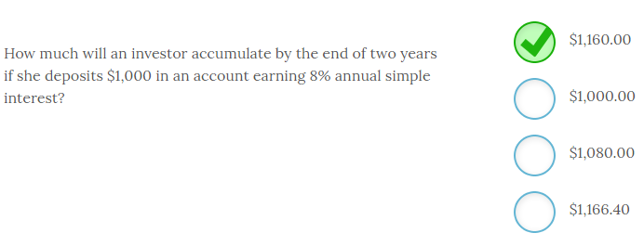

An investor will accumulate **$1,160.00**by the end of two years if she deposits $1,000 in an account earning 8% annual simple interest.

Simple interest refers to earning interest only on the original principal so this investor will earn $80 in interest ($1,000 x .08 = $80) for each year the $1,000 remains on deposit. In this case the $1,000 remains invested for two years so the investor will have the original $1,000 + $80 interest from year 1 + $80 interest from year two for a total of $1,160.

Compound interest, or the process of earning interest on the principal and reinvested interest, would result in the investor accumulating $1,166.40 by the end of two years. The process of computing the compound interest amount is FV = PV(1 + i)n = $1,000(1.08)2 = $1,166.40.

-------------------------------------------------------------------------------------------------------------------------------------------------------------------------------------------------------------

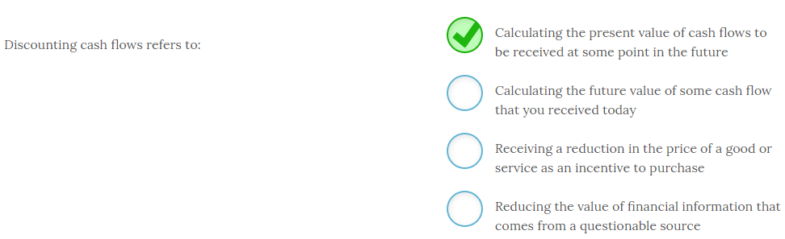

Discounting cash flows refers to **calculating the present value of cash flows to be received at some point in the future.** Discounting is the process of equating future cash flows to some value you would be indifferent to receiving today. For any positive interest rate that present value will always be lower than the sum of the future values because of the opportunity cost associated with the receipt of future cash flows.

While we often discount information received from questionable sources, or we may receive a customer discount on purchases, discounting cash flows always refers to calculating present values.

-------------------------------------------------------------------------------------------------------------------------------------------------------------------------------------------------------------

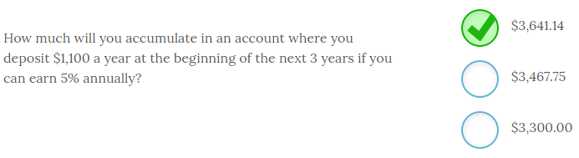

If you deposit $1,100 a year at the beginning of the next 3 years and you can earn 5% annually you will accumulate **$3,641.14** by the end of the third year. To calculate the FV of an annuity due you use the following financial calculator inputs;

So,

C = PMT = -$1,100

N = NPER = 3

I/Y = RATE = 5%

PV = 0

CPT FV = $3,467.38

For an annuity due you need to multiply this amount by (1 + r) to get the final result. So, $3,467.38(1.05) = $3,641.14. Remember that your calculator’s algorithm is set for end of period payments. Multiplying by (1 + r) corrects for the payment occurring at the beginning of the period.

Your financial calculator will also have a function that allows you to switch from BGN or END and compute the results without making the adjustment of multiplying (FV) by the factor (1 + r). When computing the PV of an annuity due you use one less period (NPER or N) and add the amount of the PMT or C to the answer you receive computing PV with one less period.

-------------------------------------------------------------------------------------------------------------------------------------------------------------------------------------------------------------

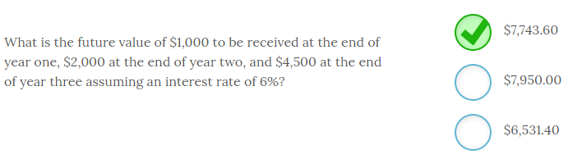

he future value of $1,000 to be received at the end of year one, $2,000 at the end of year two, and $4,500 at the end of year three assuming an interest rate of 6% is equal to **$7,743.60.**

To calculate the FV of an uneven cash flow stream you calculate the future values of the individual cash flows and sum those together. Look at the following timeline to help visualize the timing of these cash flows. In this case they are;

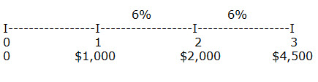

The year 1 cash flow (C) will earn 6% for 2 years, from the end of year one to the end of year 3 so FV C1 = $1,000(1.06)2 = $1,123.60. The year 2 cash flow will earn 6% for one year, from the end of year two to the end of year three so the FV C2 = $2,000(1.06) = $2,120.00. The future value of $4,500 to be received in year three is simply the $4,500.00.  Therefore the FV of the entire cash flow stream = $1,123.60 + $2,120.00 + $4,500.00 = $7,743.60. Keep in mind that the future value in this example would always exceed the sum of the actual cash flows ($7,500) for any positive interest rate.

-------------------------------------------------------------------------------------------------------------------------------------------------------------------------------------------------------------

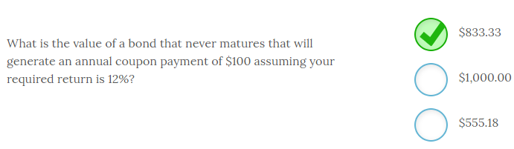

The value of a bond that never matures that will generate an annual coupon payment of $100, assuming a required return of 12%, is **$833.33.**

Perpetuity values are simply the cash flow divided by the required return so PV of a perpetuity = C/r

PV = $100/.12 = $833.33

You would be willing to pay $833.33 for this bond.

-------------------------------------------------------------------------------------------------------------------------------------------------------------------------------------------------------------

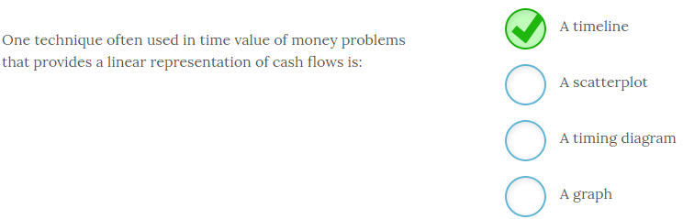

One technique often used in time value of money problems that provides a linear representation of cash flows is **a timeline**.  Timelines, like the one posted below, allow us to visually plot cash flows in order to help us solve financial problems.

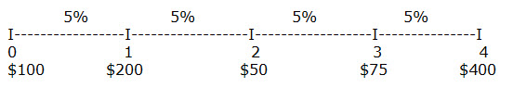

For example, look at the information plotted on this timeline and you can easily see where the cash flows occurred, the amount and direction of the cash flows, and the interest rates for each period. With this information you could easily calculate the answers to most financial questions related to this series of cash flows.

While scatterplots, diagrams, and graphs are all useful ways to summarize data they are not relevant to time value of money calculations of this nature.

-------------------------------------------------------------------------------------------------------------------------------------------------------------------------------------------------------------

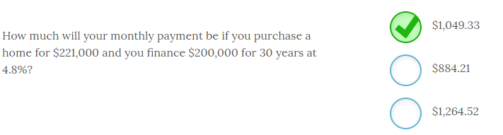

Your monthly payment will be **$1,049.33** if you purchase a home for $221,000 and you finance $200,000 for 30 years at 4.8%.

This calculation is simple with your financial calculator. You must first convert the interest rate and number of periods to monthly. So, N will be 30 years x 12 months per year = 360 months. The I/Y will be 4.8%/12 = .4% per month. Keep in mind you are only financing $200,000 of the purchase price of the home.

The calculator inputs will be;

PV = $200,000

N = NPER = 360

I/Y = RATE = .4

FV = 0

CPT PMT = -$1,049.33

You can use the formula method to solve this problem but the financial calculator makes this a very quick and easy solution. Learn to use your financial calculator.

-------------------------------------------------------------------------------------------------------------------------------------------------------------------------------------------------------------

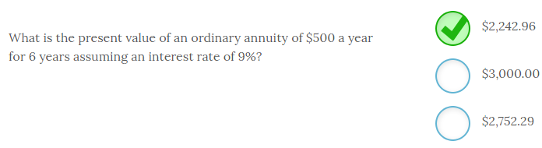

The present value of an ordinary annuity of $500 a year for 6 years assuming an interest rate of 9% is equal to **$2,242.96**. To calculate the PV of an annuity you use the following calculator keystrokes;

PMT = annuity payment

FV = future value

PV = present value

NPER = number of periods (Note that this is N on most financial calculators)

RATE = interest rate (Note that this key is I/Y on most financial calculators)

So, PMT = -$500; NPER = 6; RATE = 9; FV = 0; CPT PV = $2,242.96.

When using a financial calculator you need to put a negative sign in front of the PMT or the PV will be a negative number.

Ordinary annuities have the cash flows, or payments, occurring at the end of the period while an annuity due has the cash flows occurring at the beginning of the period.

-------------------------------------------------------------------------------------------------------------------------------------------------------------------------------------------------------------

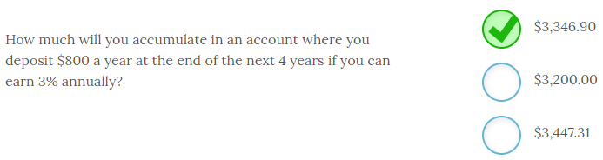

If you deposit $800 a year at the end of the next 4 years and you can earn 3% annually you will accumulate **$3,346.90** by the end of the fourth year. To calculate the FV of an ordinary annuity you use the following financial calculator inputs;

PMT = annuity payment

FV = future value

PV = present value

NPER = number of periods (Note that this is N on most financial calculators)

RATE = interest rate (Note that this key is I/Y on most financial calculators)

So, PMT = -$800; PV = 0; NPER = 4; RATE = 3; CPT FV = $3,346.90

Since you are depositing $800 per year you need to put a negative sign in front of the PMT since it is a cash outflow.

Most calculators require you to input the missing values as a zero with the exception of the value you are solving for. On a financial calculator the CPT key is compute.

-------------------------------------------------------------------------------------------------------------------------------------------------------------------------------------------------------------

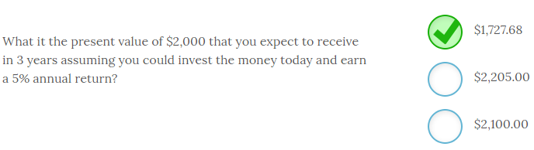

The present value of $2,000 that you expect to receive in 3 years assuming you could invest the money today and earn a 5% annual return is equal to **$1,727.68.**

To calculate the PV of a single sum you use the following formula;

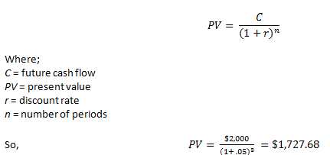

Always consider whether your answer is even possible. For example a present value will always be less than the future value for any positive rate of interest. Remember to use a timeline to identify the timing and amount of each cash flow.

-------------------------------------------------------------------------------------------------------------------------------------------------------------------------------------------------------------

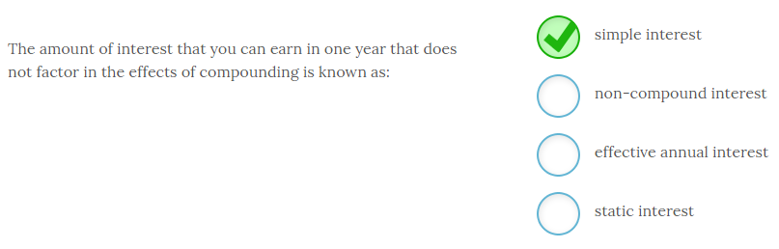

The amount of interest that you can earn in one year that does not factor in the effects of compounding is known as **simple interest**.

The simple interest rate is also often known as the APR or annual percentage rate. Conversely, compound interest rates incorporate the impact of compounding frequencies that include semiannual, quarterly, monthly or daily.

Simple interest may also be listed as the stated rate, quoted rate or nominal rate. None of these rates consider the impact of compounding.

-------------------------------------------------------------------------------------------------------------------------------------------------------------------------------------------------------------

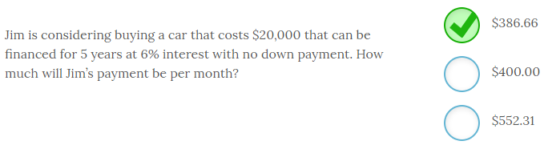

Jim’s monthly payment on a 5-year $20,000 loan at 6% interest will be **$386.66**. In order to calculate a payment you use the following financial calculator inputs;

PMT = annuity payment

FV = future value

PV = present value

NPER = number of periods (Note that this is N on most financial calculators)

RATE = interest rate (Note that this key is I/Y on most financial calculators)

So, PV = -$20,000; RATE = 6/12 months = .5; NPER = 5 year x 12 months per year = 60 months; FV = 0; CPT PMT = $386.66

Note that you must convert NPER to the number of months and RATE to a monthly interest rate. The present value is the cost of the car today, or the amount financed.

-------------------------------------------------------------------------------------------------------------------------------------------------------------------------------------------------------------  
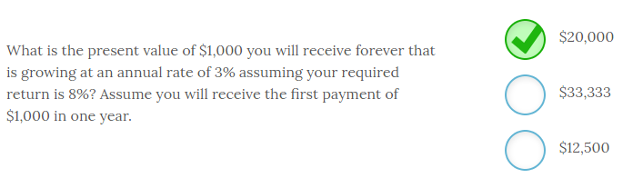

The present value of $1,000 you will receive forever that is growing at an annual rate of 3% assuming your required return is 8% and assuming you will receive the first payment of $1,000 in one year is **$20,000**. To compute the answer you use the following formula;

PV = C/(r –g) where

C = the first cash flow you will receive at the end of the next period

r = required return

g = growth rate

So, PV = $1,000/(.08 - .03) = $1,000/.05 = $20,000.

-------------------------------------------------------------------------------------------------------------------------------------------------------------------------------------------------------------

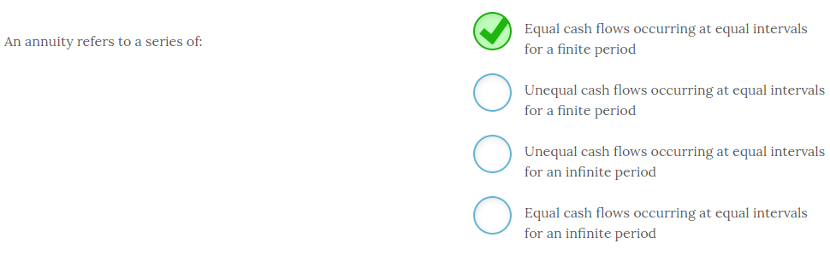

An annuity refers to a series of **equal cash flows occurring at equal intervals for a finite period.** Common annuities are car payments and mortgages. Another example of an annuity would be a series of monthly deposits you make in order to accumulate $15,000 over the next five years for a down payment on a house. In every case you will pay (or receive) an equal payment for a fixed number of months (equal intervals) to repay the loan or accumulate some amount of money.

Annuities that extend for an infinite period are known as perpetuities. And, any time the cash flows are not equivalent it is not an annuity but instead just a series of irregular or uneven cash flows.

It is important to be able to recognize an annuity because identifying whether a series of cash flows contains an annuity will make calculating present values and future values easier.

-------------------------------------------------------------------------------------------------------------------------------------------------------------------------------------------------------------

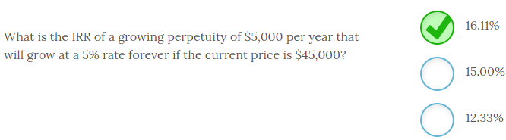

The IRR of a growing perpetuity of $5,000 per year that will grow at a 5% rate forever if the current price is $45,000 is **16.11%**.

To compute the IRR you use the following formula;

IRR of a growing perpetuity = (C/P) + g

So in this case, ($5,000/$45,000) + .05 = .1611 or 16.11%

-------------------------------------------------------------------------------------------------------------------------------------------------------------------------------------------------------------

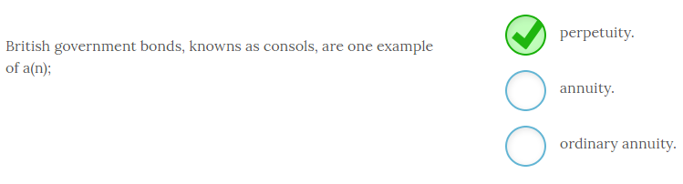

British government bonds, knowns as consols, are one example of a **perpetuity**. Perpetuities are equal cash flow streams that occur at equal intervals forever, or perpetually. Annuities are equal cash flow streams that occur at equal intervals and have a finite maturity. For an ordinary annuity the cash flow occurs at the end of each period, for example the end of each month or year.

An annuity due has cash flows that occur at the beginning of each interval or period.

-------------------------------------------------------------------------------------------------------------------------------------------------------------------------------------------------------------

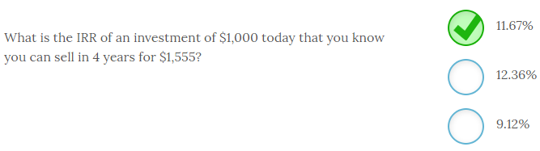

The IRR of an investment of $1,000 today that you know you can sell in 4 years for $1,555 is **11.67%**. The easiest way to solve this problem is to use your financial calculator with the following inputs;

PV = -$1,000; FV = $1,555; NPER or N = 4; PMT or C = 0; CPT I/Y or RATE = 11.67%.

You can easily check your result by using the FV formula for a single sum and plugging the IRR in as your interest rate. So, $1,000(1.1167)4 = $1,555.

-------------------------------------------------------------------------------------------------------------------------------------------------------------------------------------------------------------

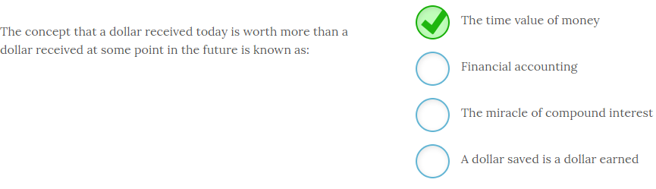

The concept that a dollar received today is worth more than a dollar received at some point in the future is known as **the time value of money.** The time value of money is one of the basic underlying principles of finance. This concept holds because we all exhibit a preference for having cash today instead of at some point in the future.

You can illustrate this point by asking all your friends if they would prefer you give them $100 today or $100 one year from now. All would prefer the $100 today because there is an opportunity cost of not receiving the money today and also a risk associated with not receiving the money today. They could deposit the money today and earn interest that would result in more than $100 at the end of the year, or they could decide to spend it today and it would buy more than it will in one year simply due to inflation. And what happens if you fall on financial hard times and could not disburse the $100 in one year? For these reasons I think you will agree there is a time value associated with the receipt of money.

-------------------------------------------------------------------------------------------------------------------------------------------------------------------------------------------------------------

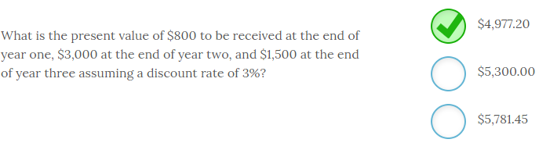

The present value of $800 to be received at the end of year one, $3,000 at the end of year two, and $1,500 at the end of year three assuming a discount rate of 3% is **$4,977.20.**

To calculate the PV of an uneven cash flow stream you calculate the present values of the individual cash flows and sum those together. Look at the following timeline to help visualize the timing of these cash flows. In this case they are;

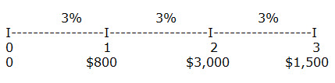

https://kf1.amplifire.com/amp/Resource?path=7bcc7a18-db97-41bb-b076-c23a5b0052ba/00/0062719e-f585-4b39-b615-3278cc7be925.png&originalFileName=Cashflow2

So, the PV of this cash flow stream = 776.70 + 2,827.79 + 1,372.71 = $4,977.20. Keep in mind that the present value in this example would always be less than the sum of the actual cash flows ($5,300) for any positive interest rate.

-------------------------------------------------------------------------------------------------------------------------------------------------------------------------------------------------------------

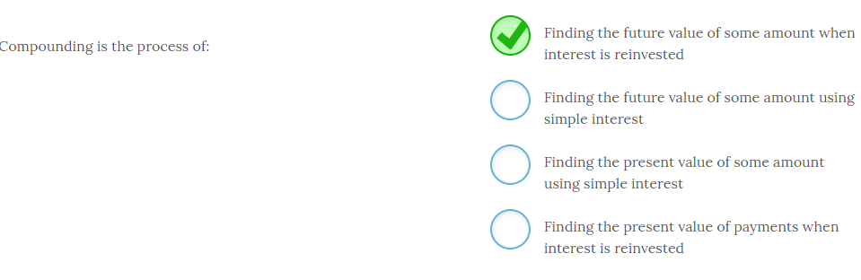

Compounding is the process of **finding the future value of some amount when interest is reinvested**.

Compounding refers to the process of adding interest back to the original principal and then earning returns on both the original principal and reinvested interest. Conversely, simple interest refers to the process of earning additional interest ONLY on the original principal and not on reinvested interest.

Compounding always refers to some point in the future so it will always deal with finding future values.

Discounting is the reverse of that process and deals with finding the present value of some amount.

-------------------------------------------------------------------------------------------------------------------------------------------------------------------------------------------------------------

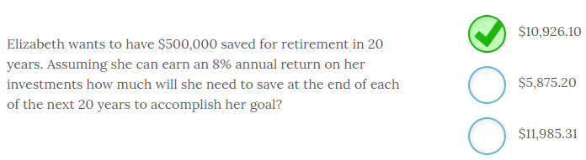

Elizabeth wants to have $500,000 saved for retirement in 20 years. Assuming she can earn an 8% annual return on her investments she will need to deposit **$10,926.10** at the end of each of the next 20 years to accomplish her goal.

Fluency with your financial calculator makes this problem easy to solve. Elizabeth has a future value in mind that she needs to accumulate in order to retire. She has a forecast annual percentage return and a time horizon in mind. With these inputs she can compute the payment she needs to make at the end of every year to accomplish her goal.

So,

FV = $500,000

N = NPER = 20

I/Y = RATE = 8%

PV = 0

CPT PMT = -$10,926.10

-------------------------------------------------------------------------------------------------------------------------------------------------------------------------------------------------------------

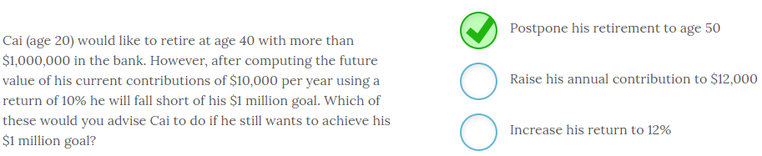

Cai (age 20) would like to retire at age 40 with more than $1,000,000 in the bank. However, after computing the future value of his current contributions of $10,000 per year using a return of 10% he will fall short of his $1 million goal. Of these options the only one that will allow Cai to achieve his $1 million goal is to **postpone his retirement to age 50.** However, you can see the FV will increase as the amount of the payment or interest rate increases, as well as time.

You can also solve for NPER or N and see how much past the age of 40 Cai would need to work. It will not be the entire 10 year period if his assumptions hold.

While increasing his return could increase his final amount it also increases risk and may not be feasible beyond some point.

-------------------------------------------------------------------------------------------------------------------------------------------------------------------------------------------------------------



The value three years from now of $3,200 deposited today that will earn an annual return of 7% is **$3,920.14**. To calculate the FV of a single sum you use the following formula;

*FVn = C x (1 + r)n*where;

*FV* = future value

*C* = present value

*r* = interest rate

*n* = number of periods

So, *FV* = $3,200(1 + .07)3 = $3,200(1.22504) = $3,920.14.

Always consider whether your answer is even possible. For example a future value will always be more than the present value for any positive rate of interest. Remember to use a timeline to identify the timing and amount of each cash flow.

-------------------------------------------------------------------------------------------------------------------------------------------------------------------------------------------------------------

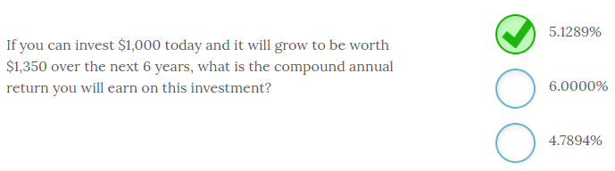

If you can invest $1,000 today and it will grow to be worth $1,350 over the next 6 years, the compound annual return you will earn on this investment is **5.1289%** per year. Using your financial calculator makes this problem easy to solve after you identify the appropriate inputs.

So,

PV = -$1,000 since you are depositing the money.

FV = $1,350

N = 6

PMT = 0

CPT I/Y or RATE = 5.1289% annual return.

You can easily check your result by the using the following formula for future value of a single sum. *FV = PV(1 + r)n* so $1,000(1.051289)6 = $1,350.08.

-------------------------------------------------------------------------------------------------------------------------------------------------------------------------------------------------------------

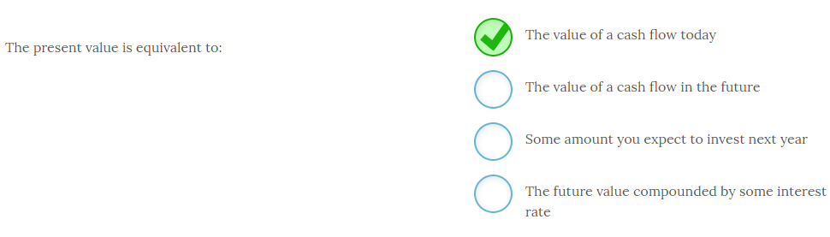

The present value is equal to **the value of a cash flow today**. When you calculate the present value of any cash flow you are finding the amount of money you would be indifferent to receiving today in lieu of some future cash flow. We often refer to the present value as time period zero to indicate that is the value now.

Any references to a value at some point in the future will always refer to future values.

# ---------------------------------------------------------------------------------------------------------------------------------------------------------------------

# Chapter 5

# ---------------------------------------------------------------------------------------------------------------------------------------------------------------------

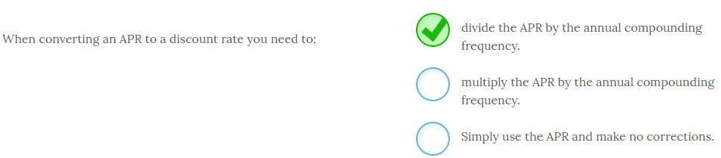

When converting an APR to a discount rate you need to **divide the APR by the annual compounding frequency**. For example, on a loan with an APR of 6% and a 4 year maturity with monthly payments you need to divide APR by 12 so you will use a monthly discount rate of .5% (i.e. 6/12). You also have to adjust for the number of periods and convert those to months. So, NPER = 4 years x 12 months = 48 months.

-------------------------------------------------------------------------------------------------------------------------------------------------------------------------------------------------------------

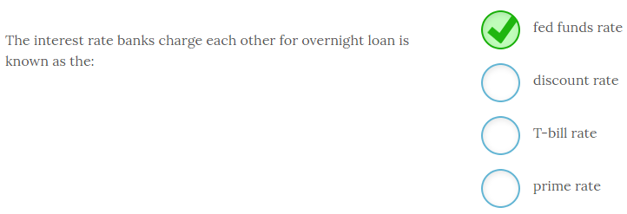

The interest rate banks charge each other for overnight loan is known as the **fed funds rate**.

The Federal Reserve uses monetary policy to achieve a targeted fed funds rate in order to stimulate economic growth or slow the economy. The Fed can influence the fed funds rate through increasing or decreasing the money supply.

In contrast, the Fed sets the discount rate, which is the rate the Fed charges to loan money to member banks that need additional reserves. The T-bill rate is the market determined rate of short-term Treasury securities known as Treasury bills. The prime rate is the interest rate that lenders charge their best (prime) customers.

All of the market determined rates are influenced by the fed funds rate. So, when the Fed alters this rate it effectively shifts most of the other interest rates in the economy.

-------------------------------------------------------------------------------------------------------------------------------------------------------------------------------------------------------------

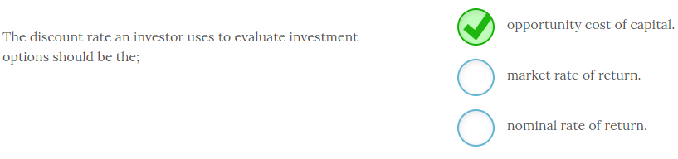

The discount rate an investor uses to evaluate investment options should be the **opportunity cost of capital.** This rate is the best available expected return offered in the market for similar risk investments. Both the nominal rate of return and the market rate of return are too ambiguous given there is no assessment of risk.

-------------------------------------------------------------------------------------------------------------------------------------------------------------------------------------------------------------

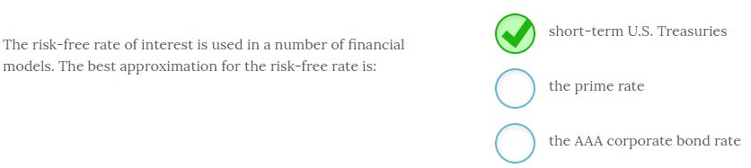

The risk-free rate of interest is used in a number of financial models. The best approximation for the risk-free rate is **short-term U.S. Treasuries**.

T-bill rates are commonly used as a proxy for the risk-free rate. This rate is useful to determine risk premiums and help calculate required returns for risky assets.

The prime rate is the rate that lenders charge their best customers. While this rate is low, it does have a risk premium to compensate lenders for some minimal level of risk. The AAA corporate bond rate is the highest or best debt rating a company could receive but it still carries some minimal risk premium and will carry a higher rate than short-term U.S. Treasuries.

-------------------------------------------------------------------------------------------------------------------------------------------------------------------------------------------------------------

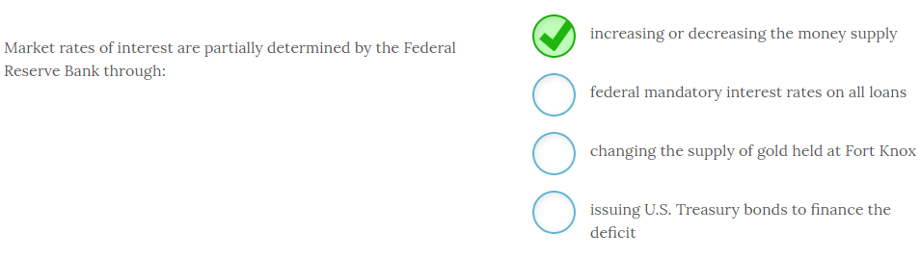

Market rates of interest are partially determined by the Federal Reserve Bank through **increasing or decreasing the money supply**.

The Federal Reserve impacts interest rates by buying or selling previously issued U.S. Treasury securities on the open market. This activity either increases the money supply (buying debt), or decreases the money supply (selling debt). This expansion or contraction of the money supply changes the equilibrium price of money which is the interest rate.

The Federal Reserve does not set any rates except the discount rate, which is the interest rate the Fed charges on loans to member banks. Other than buying and selling existing U.S. Treasury securities, the Fed has nothing to do with the issuance or redemption of U.S. Treasuries and does not manipulate the stock of gold held at Fort Knox to impact interest rates.

Note that the Treasury and the Fed are separate branches of government with different missions. The Fed is in charge of monetary policy and conducts monetary policy to promote economic growth and price level stability (i.e., inflation or deflation). Conversely, the U.S. Treasury is in charge of paying for and financing government operations. It issues U.S. Treasury securities to finance annual deficits and total debt.

-------------------------------------------------------------------------------------------------------------------------------------------------------------------------------------------------------------

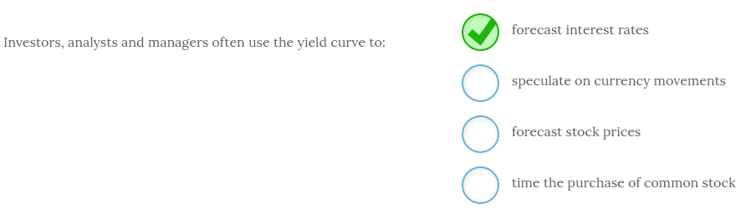

Investors, analysts and managers often use the yield curve to **forecast interest rates**.

According to expectations theory, the shape of the yield curve depends on the overall market expectation of what interest rates will be in the future. An upward sloping yield curve indicates higher interest rates are expected. Conversely, a downward sloping yield curve indicates lower interest rates are expected in the future.

Yield curves are also used to provide some indication of the direction of the overall economy and are thought to be a leading indicator of economic activity. While economic activity may be used to make other financial decisions, the shape of the yield curve is not often used, if at all, to speculate on currency movements, forecast stock prices, or time the purchase of common stock.

-------------------------------------------------------------------------------------------------------------------------------------------------------------------------------------------------------------

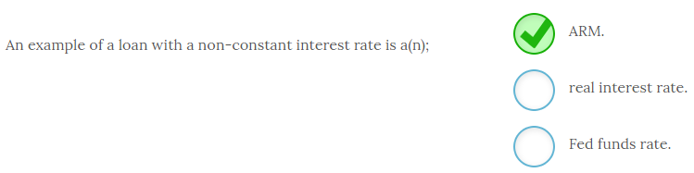

An example of a loan with a non-constant interest rate is an **ARM**, or adjustable rate mortgage. These mortgages are initially fixed for a short period of time, commonly three to five years, and then adjust every year thereafter based on a market based interest rate. These types of mortgages shift the risk of changing interest rates from the lender to the borrower.

The real interest rate is the nominal interest rate adjusted for inflation. The Fed funds rate is the rate that Federal Reserve member banks charge each other for overnight loans.

-------------------------------------------------------------------------------------------------------------------------------------------------------------------------------------------------------------

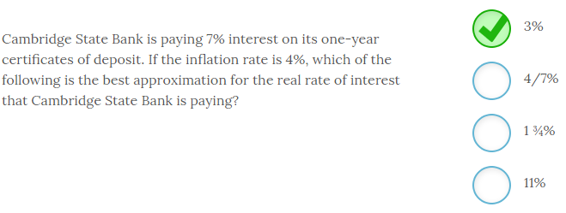

Cambridge State Bank is paying 7% interest on its one-year certificates of deposit. If the inflation rate is 4%, the best approximation for the real rate of interest that Cambridge State Bank is paying is **3%**.

The nominal or stated rate of interest can be viewed as the real rate plus an inflation premium so,

Stated rate = real rate of interest + expected inflation premium

Given the nominal rate of 7% and an inflation rate of 4%, we can simply plug those numbers into the simple formula and solve for an approximation of the real interest rate. So,

7% = real rate + 4%

Real rate = 3%

This formula was first stated by economist Irving Fisher in the 1930s and often called the Fisher equation. The impact of inflation on nominal rates of interest is called the Fisher Effect. The basic premise is that savers will demand a return at least as high as the rate of inflation so that they can have a real increase in purchasing power at maturity. If nominal interest rates are below the rate of inflation, then savers will lose purchasing power.

-------------------------------------------------------------------------------------------------------------------------------------------------------------------------------------------------------------

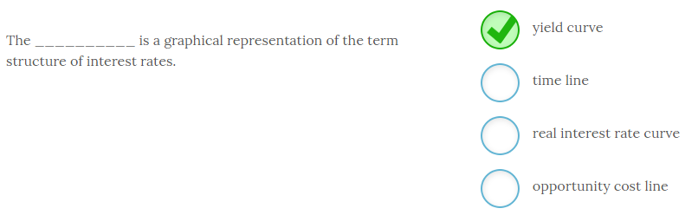

The **yield curve** is a graphical representation of the term structure of interest rates.

A yield curve is constructed from U.S. Treasury securities of differing maturities and plots yield on the y-axis and time to maturity on the x-axis. The resulting line that shows this relationship is known as the yield curve and it is typically upward sloping and to the right (normal yield curve).

A time line is a tool used in finance that plots the amount and timing of a project’s cash flows. Opportunity costs and real interest rates are not often graphed.

The yield curve can take on other shapes. For example, an inverted yield curve is a curve that is downward sloping and to the right that indicates short-term interest rates are higher than long-term interest rates. A segmented yield curve has sections of the yield curve increasing and sections of the yield curve decreasing.

-------------------------------------------------------------------------------------------------------------------------------------------------------------------------------------------------------------

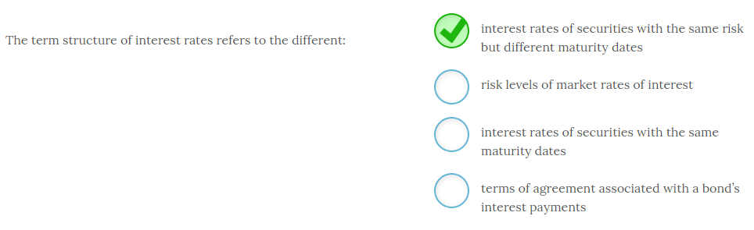

The term structure of interest rates refers to the different **interest rates of securities with the same risk but different maturity dates**.

The graphical representation of the term structure of interest rates is called the yield curve. The yield curve is constructed using U.S. Treasury securities in order to hold the risk associated with the issuer constant. This method allows you to see the exact relationship between interest rates and maturity dates without interference from other factors.

The interest rates of securities with the same maturity date will vary based on the risk of the issuer, which is not the term structure of interest rates. The terms of agreement associated with a bond’s issue are included in a document known as the indenture. These provisions provide details on all bond features and also often restrict the firm’s ability to issue new debt.

The typical or “normal” yield curve is upward sloping and to the right indicating that the market rates of interest are higher for longer term securities, holding all else constant. There are several theories that attempt to explain the term structure of interest rates that will be reviewed later.

-------------------------------------------------------------------------------------------------------------------------------------------------------------------------------------------------------------

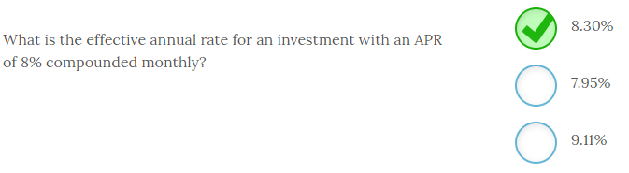

The effective annual rate when a quoted annual rate (APR) of 8% is compounded monthly is **8.30%**. To compute this rate you use the formula;

1 + EAR = [1 + APR/k]k where k = number of compounding periods per year.

So, 1 + EAR = [1 + .08/12]12 = 1.08299

So EAR = 8.30%

-------------------------------------------------------------------------------------------------------------------------------------------------------------------------------------------------------------

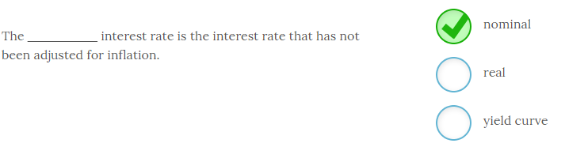

The **nominal** interest rate is the interest rate that has not been adjusted for inflation. The nominal rate, or the quoted rate, does not factor in the impact of inflation.  In contrast, the real interest rate is the nominal rate adjusted for the impact of inflation. The yield curve is constructed using interest rates of varying maturity securities from the same issuer which is typically the U.S. government.

-------------------------------------------------------------------------------------------------------------------------------------------------------------------------------------------------------------

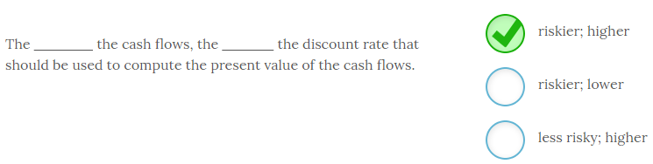

The **riskier** the cash flows, the **higher** the discount rate that should be used to compute the present value of the cash flows. There is a risk and return tradeoff in finance that exists. Specifically investors and businesses must be compensated with higher returns before they will take on more risk.

-------------------------------------------------------------------------------------------------------------------------------------------------------------------------------------------------------------

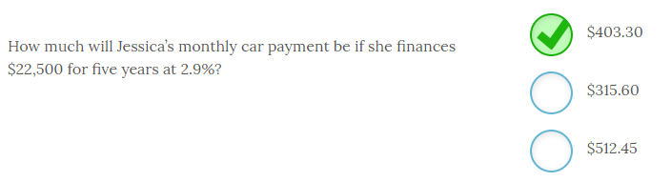

Jessica’s monthly car payment will be **$403.30** if she finances $22,500 for five years at 2.9%. To compute the payment you must first convert the time frame and interest rate to months. So, 5 years x 12 months per year = 60 months and 2.9% divided by 12 months = .2417% per month. Now you can put the following inputs into your financial calculator;

PV = -$22,500

NPER or N = 60

I/Y or RATE = .2417

FV = 0

CPT PMT = $403.30

-------------------------------------------------------------------------------------------------------------------------------------------------------------------------------------------------------------

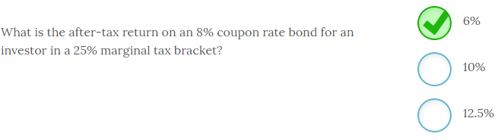

The after-tax return on an 8% coupon rate bond for an investor in a 25% marginal tax bracket is **6%**. To compute the after-tax return you multiply the nominal rate by (1 – T) where T = marginal tax rate. So, 8% x (1-.25) = 6%.

-------------------------------------------------------------------------------------------------------------------------------------------------------------------------------------------------------------

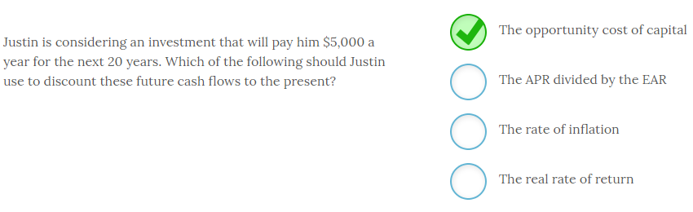

Justin is considering an investment that will pay him $5,000 a year for the next 20 years. When he makes his calculations to discount these future cash flows to the present, he needs to use **the opportunity cost of capital**.

The opportunity cost of capital is the best rate Justin could earn on a similar risk and maturity investment. He needs to make at least as much as he could on the next best comparable option or he should not make the investment.

The opportunity cost of capital will exceed the real rate of return and the rate of inflation since any market rate of return should include both of those components. The annual percentage rate (APR) divided by the effective annual rate (EAR) is simply a detractor and not used in any market in this form.

Risk averse individuals will always choose the highest possible return among assets that have the same level of risk and maturity dates. Justin is merely trying to compare his options to determine where he can get that return.

-------------------------------------------------------------------------------------------------------------------------------------------------------------------------------------------------------------

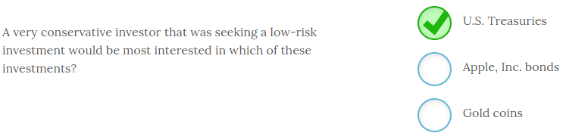

A very conservative investor that was seeking a low-risk investment would be most interested in **U.S. Treasuries**. U.S. Treasuries are essentially risk-free given the government can increase taxes to repay the debt. The next lowest risk investment is the Apple, Inc. bonds since Apple is a strong firm and bonds pay a guaranteed coupon payment. Gold coins can move up or down dramatically as the price of gold changes and gold coins do not guarantee any return.

-------------------------------------------------------------------------------------------------------------------------------------------------------------------------------------------------------------

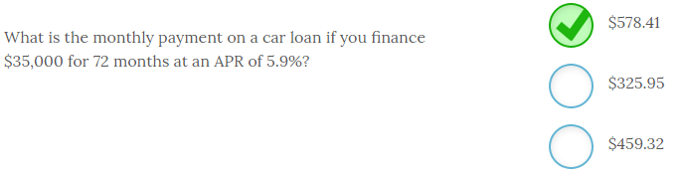

The monthly payment on a car loan if you finance $35,000 for 72 months at an APR of 5.9% is **$578.41**.

To compute the payment you need to convert the APR to a monthly interest rate so 5.9/12 = .4917% per month. Now use the following inputs in your financial calculator;

PV = $35,000

NPER or N = 72

I/Y or RATE = .4917

FV = 0

CPT C or PMT = -$578.41

Note that since you did not input the PV as a negative number you will receive a negative PMT which indicates an outflow.

-------------------------------------------------------------------------------------------------------------------------------------------------------------------------------------------------------------

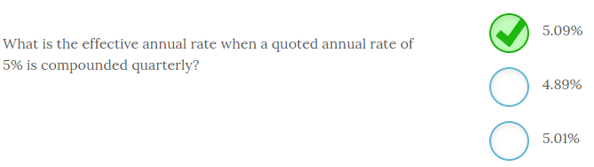

The effective annual rate when a quoted annual rate of 5% is compounded quarterly is **5.09%**. To compute this rate you use the formula;

1 + EAR = [1 + APR/k]k where k = number of compounding periods per year.

So, 1 + EAR = [1 + .05/4]4 = 1.0509

So EAR = 5.09%

The EAR will always exceed the quoted rate if the compounding frequency is greater than annual.

-------------------------------------------------------------------------------------------------------------------------------------------------------------------------------------------------------------

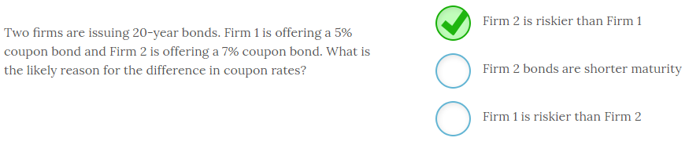

Two firms are issuing 20-year bonds. Firm 1 is offering a 5% coupon bond and Firm 2 is offering a 7% coupon bond. The likely reason for the difference in coupon rates is that **Firm 2 is riskier than Firm 1**. When a firm’s cash flows are deemed to have a higher risk of default that firm will have to offer a higher interest rate to entice investors to buy their bonds.

You will see in later chapters that other bond features such as convertibility and callability can also impact bond coupon interest rates.

-------------------------------------------------------------------------------------------------------------------------------------------------------------------------------------------------------------

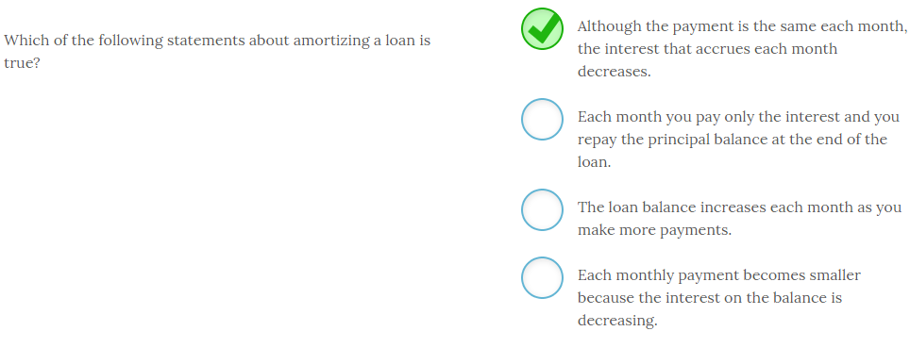

When you amortize a loan **the payment is the same each month but the interest that accrues each month decreases**.

The loan payment is calculated to be an equal monthly amount that will fully repay the loan, including any interest, by the end of the loan. Each payment will have a component that repays accrued interest to date, and then the remainder reduces the principal balance. Therefore, each successive payment has a slightly smaller interest component and a slightly larger fraction dedicated to reducing the principal. At the end of the amortization period, your equal monthly payments will have fully repaid the loan.

-------------------------------------------------------------------------------------------------------------------------------------------------------------------------------------------------------------

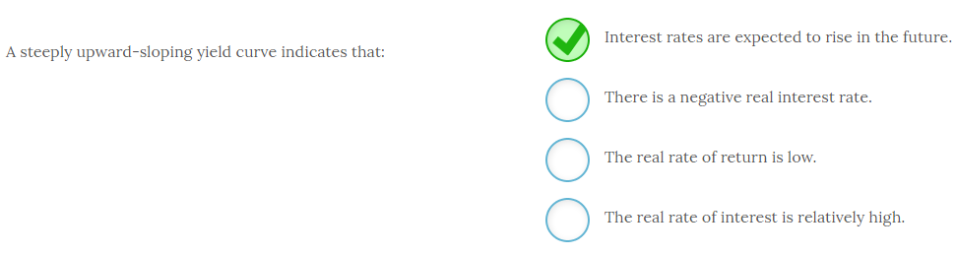

A steeply upward-sloping yield curve indicates **that interest rates are expected to rise in the future**.

According to expectations theory, the shape of the yield curve is determined by investor expectations about future interest rates. Therefore, a yield curve that sharply rises indicates that future interest rates are expected to be higher for some reason. Since the yield curve is constructed using nominal interest rates, it does not provide information on real interest rates. Therefore, without information on the inflation rates there is not enough information to determine the current real rate of return.

There are several other theories that attempt to explain the shape of the yield curve, but the expectations theory is the most widely used by academics. This theory is also known as the unbiased expectations theory or the pure expectations theory.

-------------------------------------------------------------------------------------------------------------------------------------------------------------------------------------------------------------

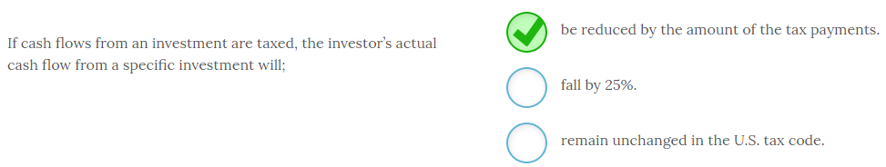

If cash flows from an investment are taxed, the investor’s actual cash flow from a specific investment will **be reduced by the amount of the tax payments**. The amount of the reduction depends on the investor’s specific marginal tax rate which varies depending on overall taxable income.

-------------------------------------------------------------------------------------------------------------------------------------------------------------------------------------------------------------

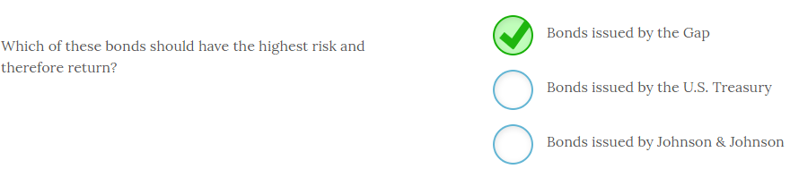

**Bonds issued by the Gap** should have the highest risk and therefore return. In contrast U.S. Treasury bonds will have the lowest risk since they are backed by the U.S. government. In addition, Johnson & Johnson is a diversified blue chip firm that has a very low risk of default compared to the Gap and will have very low rates.

Review Figure 5.4 for a list of various loan rates for these borrowers on December 2015.

-------------------------------------------------------------------------------------------------------------------------------------------------------------------------------------------------------------

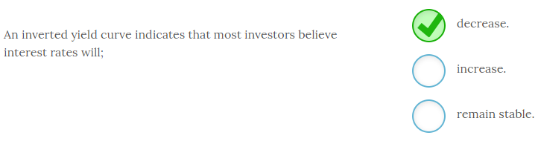

An inverted yield curve indicates that most investors believe interest rates will **decrease**. If the yield curve is inverted it is downward sloping and to the right which indicates long-term interest rates are below short-term interest rates. When this inversion occurs it indicates investors believe long-term interest rates are heading lower. Conversely, a normal yield indicates investors believe interest rates will increase.

# ---------------------------------------------------------------------------------------------------------------------------------------------------------------------

# Chapter 6

# ---------------------------------------------------------------------------------------------------------------------------------------------------------------------

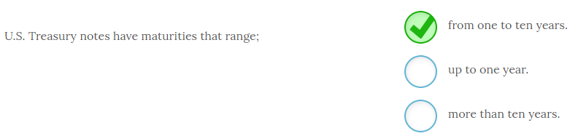

U.S. Treasury notes have maturities that range **from one to ten years**. U.S. Treasury bills have maturities up to one year and U.S. Treasury bonds have maturities that exceed ten years. All are issued by the U.S. government and therefore have low to no default risk depending on who you ask.

-------------------------------------------------------------------------------------------------------------------------------------------------------------------------------------------------------------

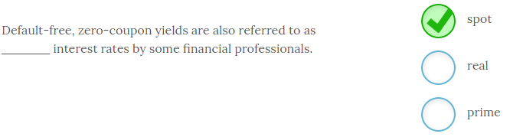

Default-free, zero-coupon yields are also referred to as **spot** interest rates by some financial professionals. This interest rate is also known as the risk-free rate of interest and will be used in successive chapters in the Capital Asset Pricing Model (CAPM).

Real interest rates are nominal interest rates that have been adjusted for inflation and the prime interest rate is the rate that lenders charge their best clients for a loan.

Forward interest rates and spot interest rates will be used when discussing financial derivatives in later chapters.

-------------------------------------------------------------------------------------------------------------------------------------------------------------------------------------------------------------

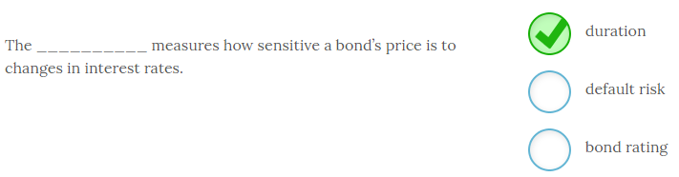

The **duration**measures how sensitive a bond’s price is to changes in interest rates.

A bond’s price moves up or down as market rates of interest change. The amount of the price change depends on coupon payments, the amount of time until the maturity date, and the amount of the change in market rates of interest. Duration is a metric used to measure a specific bond’s price sensitivity to changes in interest rates.

A bond rating is an assessment of default risk assigned by an external rating agency such as Standard and Poor’s, Moody’s, or Fitch. It doe

Duration is a tool that can be used to structure bond portfolios to take advantage of forecasted changes in interest rates or to reduce overall bond portfolio risk. Bonds with longer maturities and lower coupon rates are more sensitive to changes in the market rate of interest.

-------------------------------------------------------------------------------------------------------------------------------------------------------------------------------------------------------------

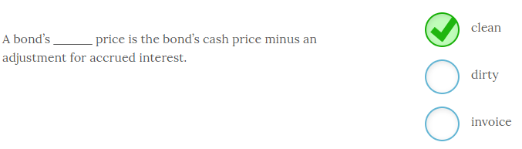

A bond’s **clean** price is the bond’s cash price minus an adjustment for accrued interest. Bonds are often quoted in clean price although bond traders know there will be an adjustment made for the accrued interest. The invoice price, or dirty price, will be the actual price paid for the bond that includes the accrued interest.

-------------------------------------------------------------------------------------------------------------------------------------------------------------------------------------------------------------

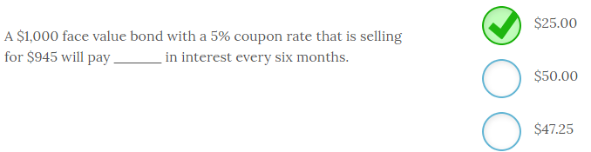

A $1,000 face value bond with a 5% coupon rate that is selling for $945 will pay **$25.00** in interest every six months. The coupon interest payment is determined by multiplying the coupon rate by the face value of the bond. If the bond is a semiannual bond you divide that annual coupon amount by two to determine the amount the bondholder will receive every six months. So, in this case $1,000 x .05 = $50 and $50/2 = $25.00 per six month period.

The bond’s current selling price is irrelevant when determining the coupon payment.

-------------------------------------------------------------------------------------------------------------------------------------------------------------------------------------------------------------

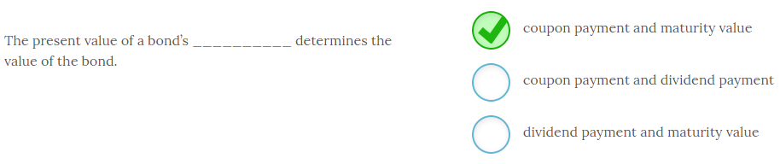

The present value of a bond’s **coupon payment and maturity value** determines the value of the bond.

The value of any asset is the present value of that asset’s cash flows. For a coupon bond, the two cash flows are the periodic coupon payments (typically, every 6 months) and the bond’s face value the bondholder receives at maturity.

Dividend payments are made to stockholders or shareholders and not bondholders.

-------------------------------------------------------------------------------------------------------------------------------------------------------------------------------------------------------------

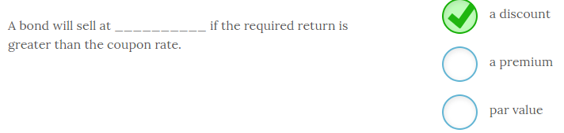

A bond will sell at **a discount** if the required return is greater than the coupon rate.

If investors demand a higher return than can be earned on the coupon rate, the value of the bond will fall until investors can buy the bond and earn a return consistent with the return they could earn on other similar risk bonds.

If they buy at a discount, they will receive the coupon payments and also earn some return on the increase in value the bond will experience as it approaches maturity. If the bond is selling at a premium, the reverse will occur. The investor will still receive the coupon payment, but will now lose money on the bond’s value as it moves toward maturity and par value.

-------------------------------------------------------------------------------------------------------------------------------------------------------------------------------------------------------------

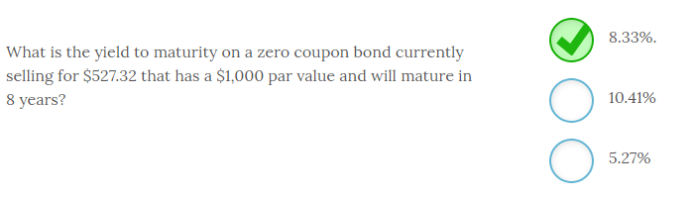

The yield to maturity on a zero coupon bond currently selling for $527.32 that has a $1,000 par value and will mature in 8 years is **8.33%**.

The easiest way to calculate the yield to maturity (YTM) is to use a financial calculator. The inputs are:

PV = -$527.32; FV = $1,000; N = 8; CPT I / Y and you get 8.33%.

You can easily check your work by taking the bond’s present value and compounding it for 8 years using the YTM as your compound rate to see if you get a future value of $1,000. So,

$527.32(1.0833)8 = $1,000.15.

As you can see, there is only a very slight rounding error.

-------------------------------------------------------------------------------------------------------------------------------------------------------------------------------------------------------------

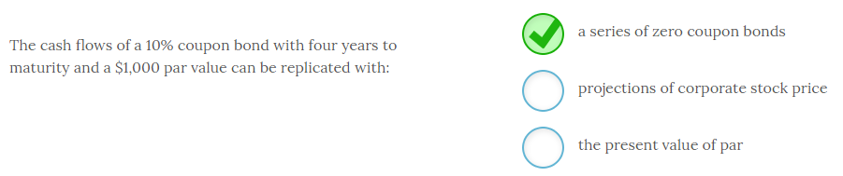

The cash flows of a 10% coupon bond with four years to maturity and a $1,000 par value can be replicated with **a series of zero coupon bonds**.

Each coupon payment of $100 can be viewed as a zero coupon bond with a specific maturity. The final zero coupon bond will also include the $1,000 maturity value of the bond, so it will be $1,100. The total value of the bond is therefore, equivalent to the sum of present value of these 4 different zero-coupon bonds.

Another way to approach it is to think of the bond’s value as the present value of a 4-year annuity of $100 plus the present value of the maturity value. Either method will generate the same result.

-------------------------------------------------------------------------------------------------------------------------------------------------------------------------------------------------------------

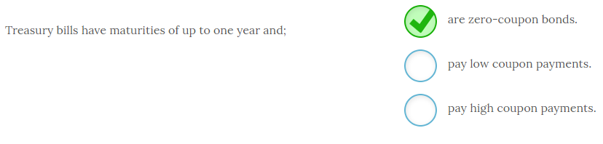

Treasury bills have maturities of up to one year and **are zero-coupon bonds**. U.S. Treasury bills are sold at a discount so investors make their return on the gain in bond value since they pay less than face value for bonds that pay face value to the bondholder at maturity. The interest rate earned is very low, given the risk-free nature of Treasury bills, but no coupon payment is paid out.-------------------------------------------------------------------------------------------------------------------------------------------------------------------------------------------------------------

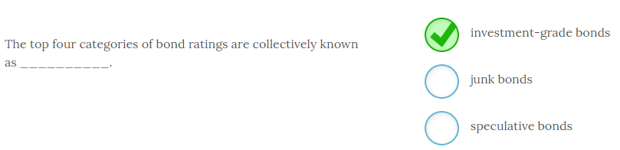

The top four categories of bond ratings are collectively known as **investment-grade bonds**.

Investment-grade bonds have a much lower risk of default than the lower rated bonds. The bottom five categories, which includes any bonds rated below Baa and BBB by Moody’s and Standard and Poor’s respectively, are known as speculative bonds or junk bonds. Junk bonds have to offer a higher return in order to compensate investors to assume a higher level of risk so they are also known as high-yield bonds

A bond can be upgraded or downgraded during its life. Even if a bond is originally issued as an investment-grade bond, the firm’s financial condition could deteriorate to the point where the bond was downgraded to junk status. The price of the bond would fall accordingly, which pushes up the yield to investors who opt to purchase the bond from other investors at this time.

-------------------------------------------------------------------------------------------------------------------------------------------------------------------------------------------------------------

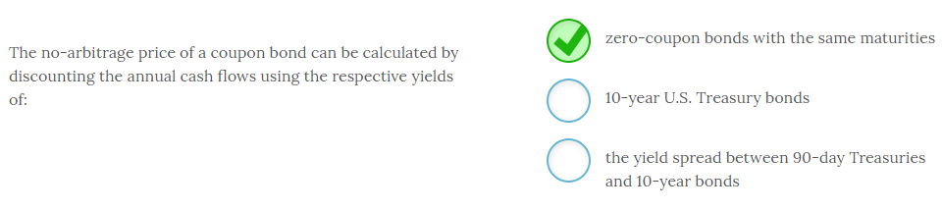

The no-arbitrage price of a coupon bond can be calculated by discounting the annual cash flows using the respective yields of **zero-coupon bonds with the same maturities**.

Note that each year’s discount rate may vary slightly since longer maturity debts typically have higher return requirements. However, this method should generate the same value as you would find using the yield to maturity as a discount rate for the overall bond value.

Computing a bond’s value using your financial calculator is the easiest way to perform the calculations regardless of method.

-------------------------------------------------------------------------------------------------------------------------------------------------------------------------------------------------------------

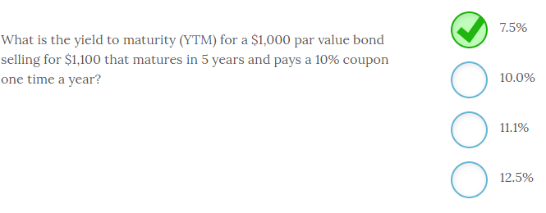

The yield to maturity (YTM) for a $1,000 par value bond selling for $1,100 that matures in 5 years and pays a 10% annual coupon one time a year is **7.5%**.

The easiest way to solve for YTM is with a financial calculator using the following inputs,

PV = -$1,100; FV = $1,000; N = 5; PMT = $100; CPT I / Y and get 7.52%.

Note that you multiply the coupon rate times the face value to get the dollar value of the coupon payment.

It is also worth noting that when a bond is selling for a premium, as in this case, the YTM will be lower than the coupon rate. So the YTM had to be below 10%.

This same process will be used to compute the internal rate of return (IRR) for capital budgeting projects.

-------------------------------------------------------------------------------------------------------------------------------------------------------------------------------------------------------------

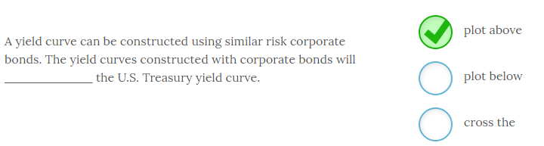

A yield curve can be constructed using similar risk corporate bonds. The yield curves constructed with corporate bonds will **plot above** the U.S Treasury yield curve.

This is because corporate bonds will have a higher risk of default than the comparable Treasury bond, so the corporate bonds will have a higher yield. However, the yield curves will tend to run in a parallel fashion and should not cross at any point.

The distance between the U.S. Treasury yield curve and the corporate bond yield curve represents the default risk premium since U.S. Treasuries are considered risk free. This default risk premium is also known as the default spread.

-------------------------------------------------------------------------------------------------------------------------------------------------------------------------------------------------------------

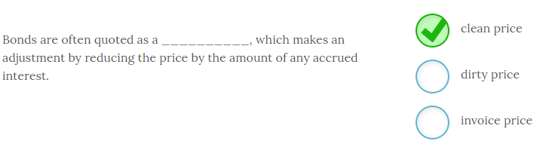

Bonds are often quoted as a **clean price**, which makes an adjustment by reducing the bond’s price by the amount of any accrued interest.

Since coupon bonds pay periodic interest payments, the value of the bond will fall by the amount of the interest payment immediately after the payment is made.

After that point, the value of the bond will gradually rise again as interest due accrues, up to the point where another coupon payment is made and the value falls again by the amount of the coupon. For this reason, the bond prices are often quoted as a clean price, which subtracts the value of the accrued interest at that point in time. A dirty price, or an invoice price, includes the value of the accrued interest. The clean price ignores the value of accrued interest, but when the transaction completes the invoice price will be adjusted to reflect the value of the accrued interest.

U.S. bond markets typically quote the clean price. Bond traders know an adjustment will be made for accrued interest, but the clean price removes the problem associated with having to specifically determine how many days it is until the next coupon payment just to value the bond.

-------------------------------------------------------------------------------------------------------------------------------------------------------------------------------------------------------------

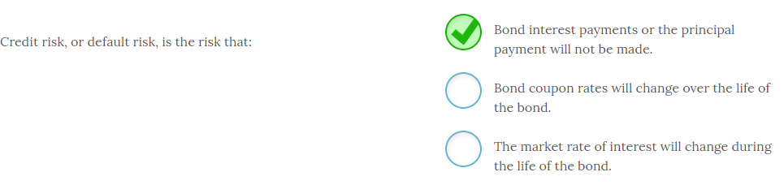

Credit risk, or default risk, is the risk that **bond interest payments or the principal payment will not be made**.

No investor can know for certain whether a corporation will be able to service its debt. This possibility of non-payment is known as credit risk or default risk and higher credit risk bonds must pay higher interest rates to compensate investors for assuming this level of risk.

Coupon rates remain fixed for the life of a bond and the risk associated with changing market rates of interest is known as interest rate risk.

-------------------------------------------------------------------------------------------------------------------------------------------------------------------------------------------------------------

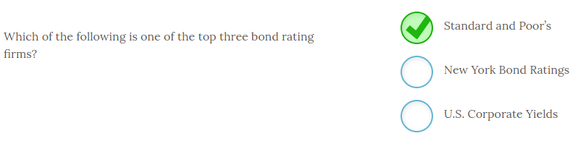

**Standard and Poor’s** is one of the top three bond rating firms.

The other two large bond rating firms are Moody’s and Fitch Ratings. All three of these firms rate debt issues with regard to default risk. The highest rated bonds are the ones that are less likely to default. The other two answer options are fictitious firms.

Corporations pay these firms to rate their debt prior to issue. Without an external bond rating it is almost impossible to sell debt, so it is a necessary part of the bond issue process to subject the firm to this external scrutiny. And, the better the rating the lower the coupon payment the firm will need to offer investors.

-------------------------------------------------------------------------------------------------------------------------------------------------------------------------------------------------------------

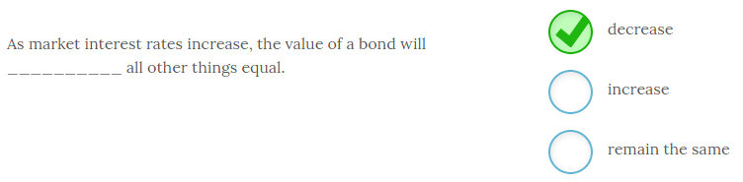

As market interest rates increase, the value of a bond will **decrease** all other things equal.

There is an inverse relationship between the values of outstanding bonds and market rates of interest. When interest rates go up, it decreases the present value of the cash flows associated with an outstanding bond and pushes price (value) lower. When interest rates go down, it increases the present value of the cash flows associated with an outstanding bond and bond prices will move higher.

-------------------------------------------------------------------------------------------------------------------------------------------------------------------------------------------------------------

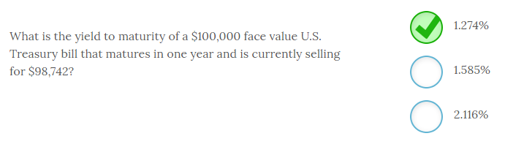

The yield to maturity of a $100,000 face value U.S. Treasury bill that matures in one year and is currently selling for $98,742 is **1.274%.** To compute the YTM you can use your financial calculator with the following inputs;

PV = -98,742

FV = 100,000

NPER or N = 1

PMT or C = 0

CPT YTM or I/Y = 1.274%

Remember that U.S. Treasury bills are sold at a discount and do not make coupon payments.

-------------------------------------------------------------------------------------------------------------------------------------------------------------------------------------------------------------

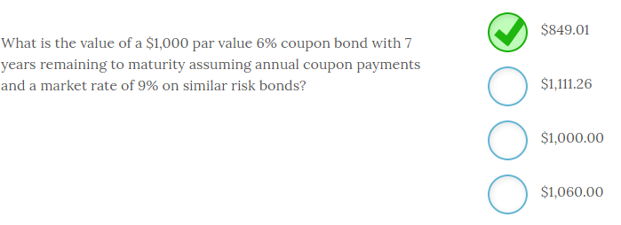

The value of a $1,000 par value 6% coupon bond with 7 years remaining to maturity assuming annual coupon payments and a market rate of 9% on similar risk bonds is **$849.01**.

The easiest way to calculate the bond’s value is to use a financial calculator with the following inputs,

FV = $1,000; PMT = $60; N = 7; I/Y = 9%; CPT PV and you get $849.01.

Note that some financial calculators will generate a negative number for PV, but you simply take the absolute value.

It is worth noting that the answer will always be less than the par value when the market rate or discount rate is greater than the coupon rate. If the discount rate is lower than the coupon rate, the bond will sell at a premium.

-------------------------------------------------------------------------------------------------------------------------------------------------------------------------------------------------------------

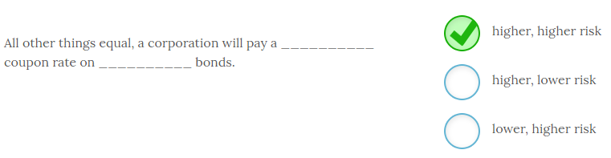

All other things equal, a corporation will pay a **higher** coupon rate on **higher risk** bonds.

As the risk of a bond increases, corporations will have to offer a higher rate to compensate investors enough to hold higher risk bonds. Conversely, lower risk bonds will carry lower coupon rates because they have a lower chance of default.

* + One of the basic premises of finance is that there is a risk-return tradeoff for all investments. Higher risk investments of any type have to offer higher returns to investors to be able to attract funds.

-------------------------------------------------------------------------------------------------------------------------------------------------------------------------------------------------------------

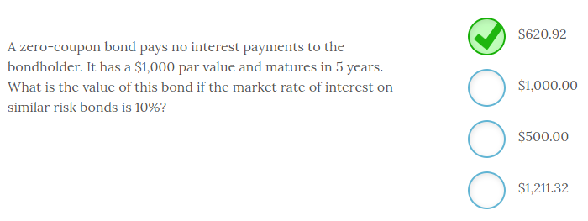

A zero-coupon bond pays no interest payments to the bondholder. It has a $1,000 par value and matures in 5 years. The value of this bond when the market rate of interest on similar risk bonds is 10% is **$620.92**.

The value of a zero-coupon bond is easy to calculate. Any bond value is simply the present value of the bond’s cash flows and a zero-coupon bond only has one cash flow; the face value received at maturity. So, the value of this bond is equal to,

PV = $1,000 / (1.10)5 = $620.92.

To value a zero-coupon bond you always use a discount rate that is equivalent to the current market rates on similar risk bonds.

You can identify similar risk bonds by looking at bond ratings. The major bond rating firms, like Standard and Poor’s and Fitch, will rate bonds prior to issue and track them throughout their life. So, all you have to do is look up the current market rate of interest for bonds that have the same debt rating.

-------------------------------------------------------------------------------------------------------------------------------------------------------------------------------------------------------------

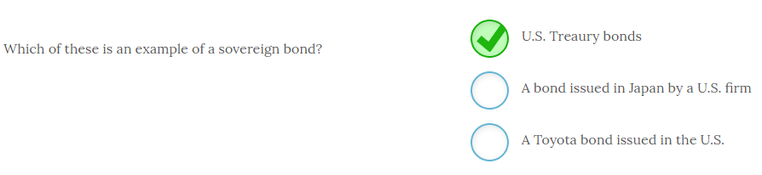

**U.S. Treasury bonds** are an example of a sovereign bond. Any bond issued by a national government is a sovereign bond. This market has received scrutiny over recent credit downgrades of bonds issued by the governments of Greece, Spain, Portugal and many others. The other bonds are corporate bonds since they are issued by firms in order to raise funds.

-------------------------------------------------------------------------------------------------------------------------------------------------------------------------------------------------------------

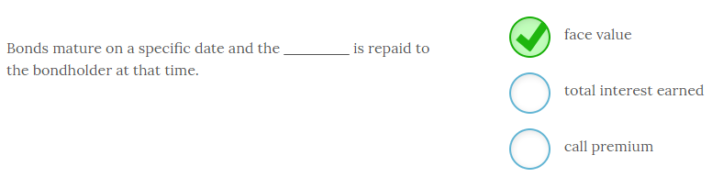

Bonds mature on a specific date and the  **face value** is repaid to the bondholder at that time. The bond’s principal, also known as face value or par value, is typically $1,000 or some multiple of $1,000.  When the bond reaches its specified maturity date that amount is returned to the bondholder.

For coupon bonds the interest is paid periodically, typically every six months, over the life of the bond. When bonds are called prior to the maturity date the bondholders will receive a call premium that is added to the face value of the bond.

-------------------------------------------------------------------------------------------------------------------------------------------------------------------------------------------------------------

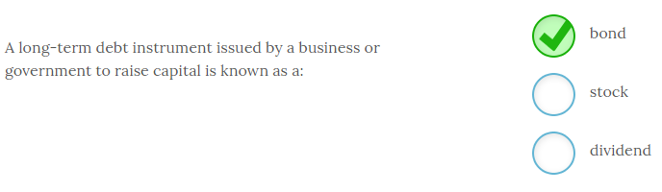

A long-term debt instrument issued by a business or government to raise capital is known as a **bond**.

Bonds are issued to raise money for operations or to acquire or improve assets. A bond typically pays interest every six months based on the coupon rate and then at maturity the bondholder will receive the face value of the bond, typically $1,000.

Stocks are a fractional ownership in a company and therefore a part of equity and not debt. Dividends are a periodic distribution of cash to the stockholders of a firm.

There are numerous types of bonds and bond features. Bonds may pay interest or simply be sold at a deep discount.

-------------------------------------------------------------------------------------------------------------------------------------------------------------------------------------------------------------

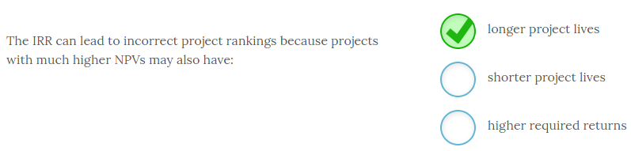

The IRR can lead to incorrect project rankings because projects with much higher NPVs may also have **longer project lives**.

A particular project could have a very high IRR and only last one year. Therefore, a project with a slightly lower IRR that lasts several years may be preferred over the higher IRR. The NPV will correctly rank these projects if you rank them from the highest NPV to the lowest NPV.

A shorter project life may or may not be the best project but the IRR will not make a distinction in project life. And, if the NPV is computed with a required return higher than the IRR it will generate a negative result and, therefore, should not be accepted.

Always use the NPV in addition to other evaluation tools. It will always generate the correct accept/reject decision and project ranking.

-------------------------------------------------------------------------------------------------------------------------------------------------------------------------------------------------------------

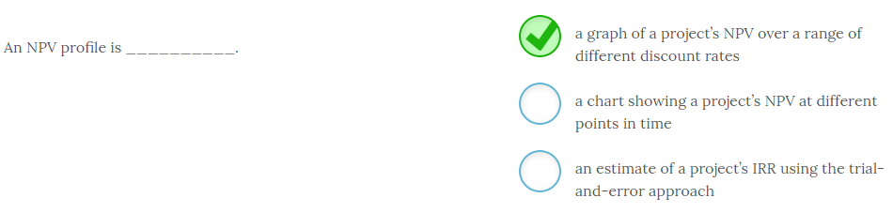

An NPV profile is **a graph of a project’s NPV over a range of different discount rates**.

An NPV profile is useful when there is uncertainty surrounding a project’s cost of capital. Some firms may use different costs of capital for projects with different levels of risk. When this is the case, the NPV profile provides some additional information regarding the discount rate where the NPV turns negative.

The NPV of a project should be calculated using all cash flows and so looking at an NPV at various points in time is meaningless. Estimating the IRR using trial-and-error is cumbersome given the computing tools available today and it has no bearing on a project’s NPV.

Make use of the spreadsheet software available to you to calculate NPV profiles and IRRs. Both processes are much easier to do with computers even though you may be forced to do one by hand to ensure you understand the process.

-------------------------------------------------------------------------------------------------------------------------------------------------------------------------------------------------------------



One pitfall of using the IRR occurs when **cash flows change signs**. The IRR technique will generate a unique IRR every time the cash flows change signs and result in multiple IRRs. There is no clear way to tell which one to use so the technique is invalid with cash flows that change directions. The IRR works well for stand alone projects and projects that begin immediately as long as all the cash inflows are positive. Delayed projects can result in an inaccurate accept decision.

-------------------------------------------------------------------------------------------------------------------------------------------------------------------------------------------------------------

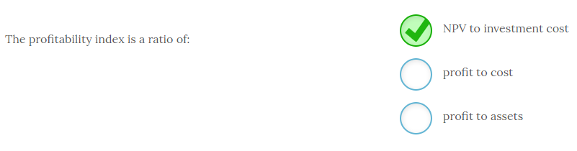

The profitability index is a ratio of **NPV to investment cost**.

The profitability index (PI) is calculated by taking a project’s NPV and dividing it by the cost. This gives us a measure of “bang for the buck”, or how much NPV will you generate per unit of resources (costs) consumed. The PI allows you to rank projects if resources are limited.

Profit to cost and profit to assets are not typically used in project analysis but are instead used to analyze efficiency in operations.

To make it easier to interpret, some practitioners add a 1 to the PI so that you end up with a number that lets you know the dollar return for each dollar invested. For example, a PI of 1.31 tells you that you will generate $1.31 for each $1.00 invested in this project. Any PI less than $1.00 should not be undertaken.

-------------------------------------------------------------------------------------------------------------------------------------------------------------------------------------------------------------

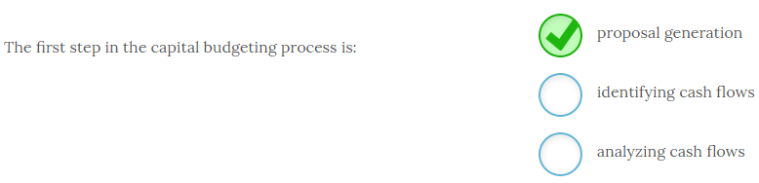

The first step in the capital budgeting process is **proposal generation**.

In order to evaluate a project you need to identify some promising capital budgeting projects that are consistent with your firm’s mission and strategy. These ideas are often generated by the executive team but they can emerge from suggestions made by the sales force, research and development, or a number of other avenues.

Once you have identified some possible proposals you will need to identify all relevant cash flows and then you can analyze the project using tools such as NPV, IRR, and payback.

Projects can emerge from almost anywhere and can include the acquisitions of existing firms, new product development, expansion of existing product lines, moving into new geographic markets, and a host of other options.

-------------------------------------------------------------------------------------------------------------------------------------------------------------------------------------------------------------



Projects that do not compete with one another so that the acceptance of one project will have no bearing on the acceptance of other projects being considered by the firm are known as **stand-alone projects**. Accepting an independent project does not automatically reject a competing project so the accept/reject decision is a stand-alone decision.

Mutually exclusive projects are projects where the acceptance of one project automatically means we are rejecting other options. This type of capital budgeting decision is common in equipment replacement decisions.

Common examples of mutually exclusive projects are when you are faced with constructing a factory that requires more workers and therefore less automation versus the decision to use robotics. You can manufacture your product using either method but you will only choose one.

-------------------------------------------------------------------------------------------------------------------------------------------------------------------------------------------------------------

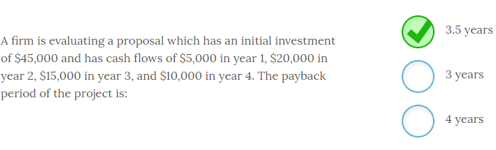

A firm is evaluating a proposal which has an initial investment of $45,000 and has cash flows of $5,000 in year 1, $20,000 in year 2, $15,000 in year 3, and $10,000 in year 4. The payback period of the project is **3.5 years**.

The payback period is the length of time it takes to recover the initial investment so in this case you see that a total of $40,000 is recovered in the first three years, which leaves $5,000 to be recovered. In the fourth year, you will generate $10,000 so the fraction of the year required to capture the remaining $5,000 investment is $5,000/$10,000 or 0.5. The payback period is, therefore, 3.5 years.

-------------------------------------------------------------------------------------------------------------------------------------------------------------------------------------------------------------

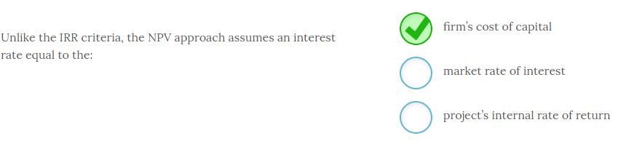

Unlike the IRR criteria, the NPV approach assumes an interest rate equal to the **firm’s cost of capital**.

The NPV uses the firm’s cost of capital to discount the project cash flows back to the present. Therefore, any positive NPV project earns at least the firm’s cost of capital.

The market rate of interest can be quite different depending on the riskiness of the firm’s business activities and the project’s internal rate of return is the discount rate that makes the project’s NPV = 0. This rate will likely have no resemblance to the firm’s cost of capital for most projects.

Any positive NPV project has an IRR that exceeds the firm’s cost of capital. However, some positive NPV projects will have much higher IRRs than others.

-------------------------------------------------------------------------------------------------------------------------------------------------------------------------------------------------------------

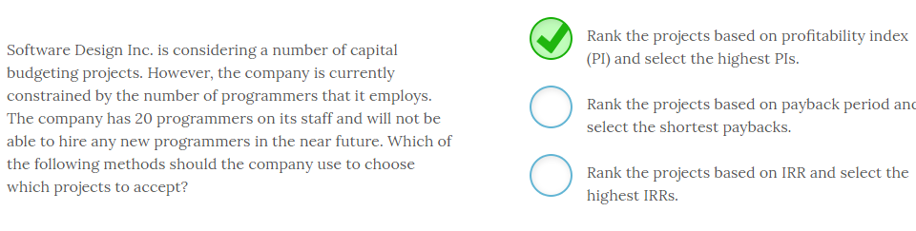

Software Design, Inc. is considering a number of capital budgeting projects. However, the company is currently constrained by the number of programmers that it employs. The company has 20 programmers on its staff and will not be able to hire any new programmers in the near future. The company should choose which projects to accept by **ranking the projects based on profitability index (PI) and selecting the highest PIs**.

When you are resource constrained, the PI will give you a metric that tells you how much “bang for the buck” you get. In this case, you would generate a PI that gives you the amount of NPV per programmer and select the highest ones until you have allocated 20 programmers.

The payback period and the IRR do not take into consideration the resource shortage you face. In this case, it is a skilled labor shortage and you need to select the projects that give the highest return per unit of skilled labor.

* + PI is commonly used to rank projects according to the amount of profit per dollar invested but you can see it has other applications when facing resource constraints that are not monetary.

-------------------------------------------------------------------------------------------------------------------------------------------------------------------------------------------------------------

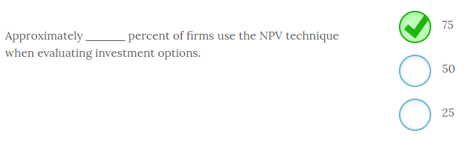

Approximately **75** percent of firms use the NPV technique when evaluating investment options. However this information is from a survey conducted in 2001 so the number is likely higher now. As more and more recent business graduates move up in the work force the technique will probably grow in popularity.

-------------------------------------------------------------------------------------------------------------------------------------------------------------------------------------------------------------

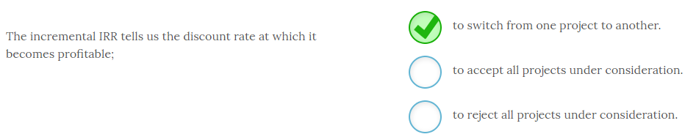

The incremental IRR tells us the discount rate at which it becomes profitable **to switch from one project to another**. This IRR is the IRR of the incremental cash flows that would result from switching from one project to another. Using this method allows us the evaluate the switch using the IRR rule and not have to directly compare the projects. This method is useful when two projects differ in risk and thus have two different cost of capital hurdle rates to compare with the IRR.

-------------------------------------------------------------------------------------------------------------------------------------------------------------------------------------------------------------

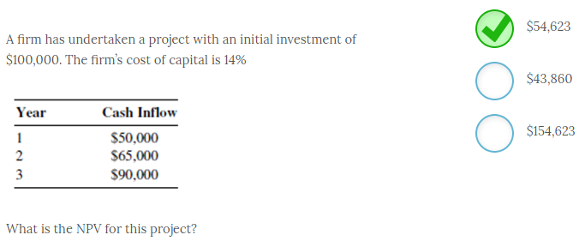

A firm has undertaken a project with an initial investment of $100,000. The firm’s cost of capital is 14%

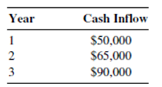

The NPV for this project is **$54,623**. You calculate the NPV for this project by subtracting the initial investment from the present value of the project’s cash flows calculated using the firm’s cost of capital. So for this project the;

NPV = $50,000/(1.14) + $65,000/(1.14)2 + $90,000/(1.14)3 - $100,000

= $43,860 + $50,015 + $60,748 - $100,000 = $54,623

-------------------------------------------------------------------------------------------------------------------------------------------------------------------------------------------------------------

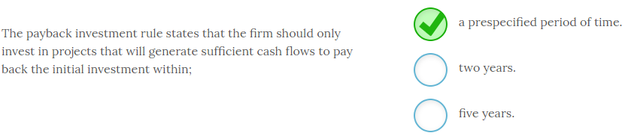

The payback investment rule states that the firm should only invest in projects that will generate sufficient cash flows to pay back the initial investment within **a prespecified period of time**. Most payback periods are a few years and two years is commonly used as a threshold. However, each firm will identify its payback period in advance and apply the rule accordingly.

The payback rule does not consider the time value of money but some financial managers use the discounted payback investment rule and use the present value of the cash flows to compute the payback period.

-------------------------------------------------------------------------------------------------------------------------------------------------------------------------------------------------------------

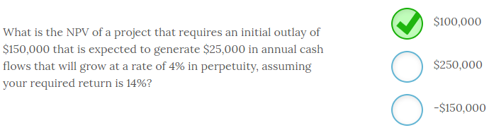

The NPV of a project that requires an initial outlay of $150,000 that is expected to generate $25,000 in annual cash flows that will grow at a rate of 4% in perpetuity, assuming your required return is 14%, is **$100,000**. To compute the answer you must use the constant growth formula to get the present value of the project’s perpetual cash flows. So,

NPV = -$150,000 + $25,000/(.14 - .04) = -$150,000 + $250,000 = $100,000

-------------------------------------------------------------------------------------------------------------------------------------------------------------------------------------------------------------

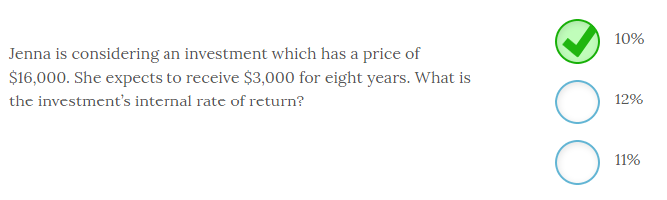

Jenna is considering an investment which has a price of $16,000. She expects to receive $3,000 for eight years. The investment’s internal rate of return is **10%**.

When you have a series of cash flows that represent an annuity it is very easy to calculate the IRR with your financial calculator using the following inputs:

* PV = -$16,000
* N = 8; FV = 0
* PMT = $3,000
* CPT I/Y, which gives you 10.0082 or approximately 10%.

Note that you would then compare this interest rate to your required return or hurdle rate to determine whether or not to accept this project.

The IRR of an uneven cash flow stream can also be calculated with a financial calculator by inputting the cash flows for each year and then solving. Note that this process is a trial and error process if you do not use a spreadsheet or calculator that has this functionality.

-------------------------------------------------------------------------------------------------------------------------------------------------------------------------------------------------------------

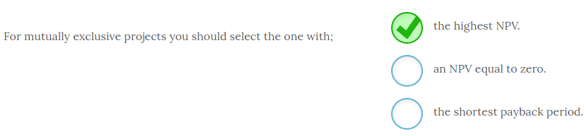

For mutually exclusive projects you should select the one with **the highest NPV**. Projects with the highest NPV will increase the investor’s wealth more since that is the cash value expressed in today’s dollars. The payback period should only be used in conjunction with the NPV and never as a stand alone tool.

-------------------------------------------------------------------------------------------------------------------------------------------------------------------------------------------------------------

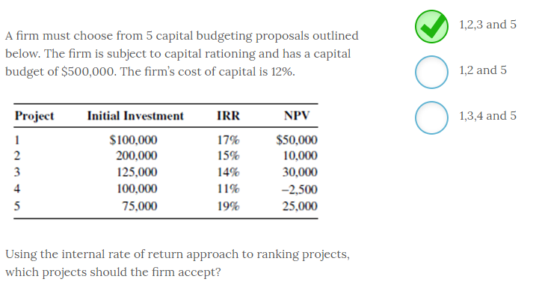

A firm must choose from 5 capital budgeting proposals outlined below. The firm is subject to capital rationing and has a capital budget of $500,000. The firm’s cost of capital is 12%.

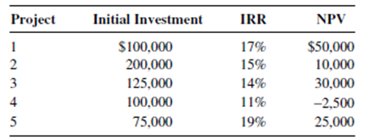

Using the internal rate of return approach to ranking projects, the firm should accept projects **1,2,3 and 5**.

Using IRR, the firm should accept any project that generates an IRR at least as high as the firm’s cost of capital. The only project that does not exceed the firm’s 12% cost of capital is project 4.

The cost of capital is also called the required return or sometimes the hurdle rate. If the projects do not generate an IRR high enough to clear the 12% hurdle then they should be rejected.

-------------------------------------------------------------------------------------------------------------------------------------------------------------------------------------------------------------

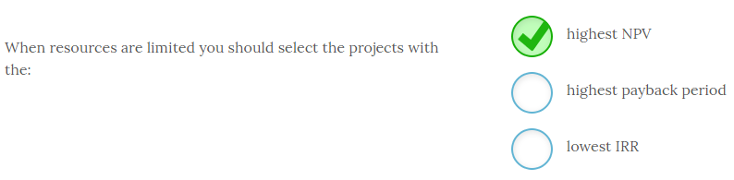

When resources are limited you should select the projects with the **highest NPV**.

The highest NPV project will contribute the most toward increasing shareholder wealth.

If the payback period is used as a selection tool, you select the projects with shorter paybacks instead of longer ones. However, payback should never be used in isolation but instead used in conjunction with the NPV.

When you use IRR as the selection tool, you will be looking for the highest IRR, not the lowest. The IRR should also be used in conjunction with the NPV and never in isolation.

The NPV is the only capital budgeting tool that will always generate the correct accept/reject decision and the best project ranking. However, when resources are constrained you can use the profitability index to help make the appropriate project selection.

-------------------------------------------------------------------------------------------------------------------------------------------------------------------------------------------------------------

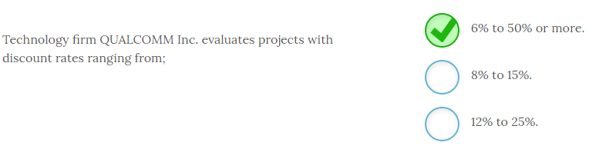

Technology firm QUALCOMM Inc. evaluates projects with discount rates ranging from **6% to 50% or more**. Very low risk projects may be evaluated using a 6% rate while high risk international projects with a lot of cash flow uncertainty may be evaluated with a discount rate of 50% or more.

The range in discount rates shows one way firms adjust for risk in capital budgeting. Higher risk projects will be evaluated with a higher discount rate and therefore are less likely to be accepted.

-------------------------------------------------------------------------------------------------------------------------------------------------------------------------------------------------------------

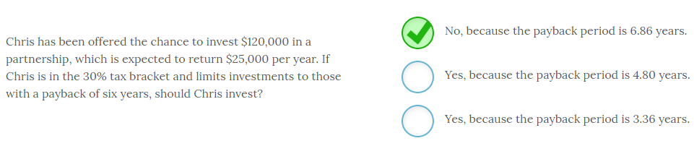

Chris has been offered the chance to invest $120,000 in a partnership, which is expected to return $25,000 per year. If Chris is in the 30% tax bracket and limits investments to those with a payback of six years, should Chris invest? **No, because the payback period is 6.86 years.**

To calculate the payback you need to calculate Chris’ annual cash return which is equal to $25,000 (1 - 0.30) = $17,500 per year in after-tax proceeds from the investment. Given that annual amount, his payback is equal to $120,000 / $17,500 = 6.86 years. Since the payback exceeds his six year cut off he should not make the investment.

Since Chris is in a 30% tax bracket that means he gets to keep 70% of his earnings and he remits 30% in taxes. So, to get his after-tax benefit you can multiply the amount by (1 – T), where T = marginal tax rate. So, (1 - 0.30) gives you the 70% after-tax fraction he gets to keep.

-------------------------------------------------------------------------------------------------------------------------------------------------------------------------------------------------------------

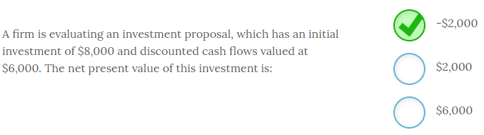

A firm is evaluating an investment proposal, which has an initial investment of $8,000 and discounted cash flows valued at $6,000. The net present value of this investment is **-$2,000**.

The NPV is defined as the present value of the project’s cash flows minus the initial investment. In this case:

NPV = $6,000 - $8,000 = -$2,000.

This project should be rejected since it has a negative NPV. The present value of the project’s cash flows needs to be at least as much as the initial investment.

If the NPV was zero or higher you would accept the project since a zero NPV means the project generated your minimum required return.

-------------------------------------------------------------------------------------------------------------------------------------------------------------------------------------------------------------

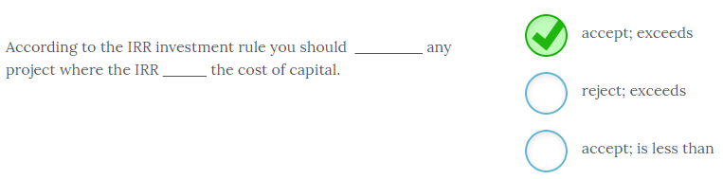

According to the IRR investment rule you should **accept** any project where the IRR **exceeds** the cost of capital. For example, if a project is expected to generate an IRR of 15% and the firm’s cost of capital is 12% undertaking this project will create shareholder wealth.

Keep the primary goal of the firm in mind. Financial managers should be investing in projects that move the stock price higher.

-------------------------------------------------------------------------------------------------------------------------------------------------------------------------------------------------------------

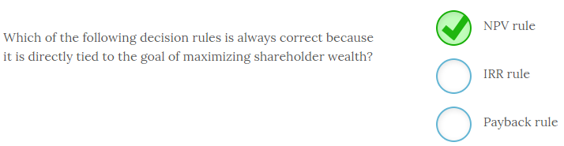

The **NPV rule** is always correct because it is directly tied to the goal of maximizing shareholder wealth.

Any project that generates a positive NPV will provide the firm’s required return since it was used as the discount rate to compute the present value of the project’s cash flows. Therefore, any positive NPV project will continue to increase shareholder wealth since a positive number means it generates returns even higher than the required return.

The IRR rule can generate incorrect accept/reject decisions if the project’s cash flows change signs. The payback rule ignores the time value of money and can be inaccurate as well, particularly in rejecting good projects that have large cash flows occurring later in the project’s life.

-------------------------------------------------------------------------------------------------------------------------------------------------------------------------------------------------------------

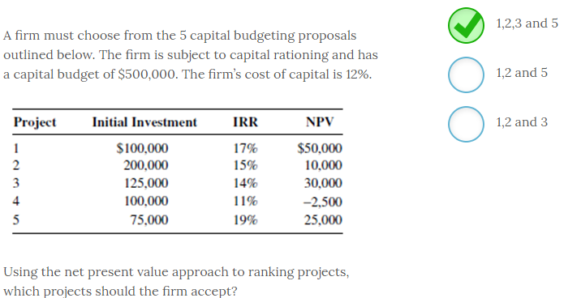

A firm must choose from 5 capital budgeting proposals outlined below. The firm is subject to capital rationing and has a capital budget of $500,000. The firm’s cost of capital is 12%.



Using the net present value approach to ranking projects, the firm should accept projects **1,2,3 and 5**.

According to the net present value decision rule, you should accept any project with a positive NPV. Any project with a positive NPV makes at least the minimum required return. Therefore, the only project that should not be accepted is project 4.

-------------------------------------------------------------------------------------------------------------------------------------------------------------------------------------------------------------

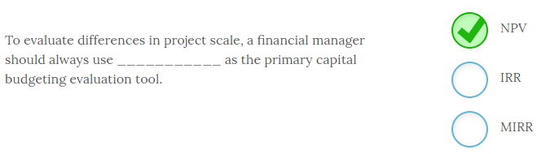

To evaluate differences in project scale, a financial manager should always use **NPV** as the primary capital budgeting evaluation tool.

If a manager looks only at the IRR as an evaluation tool they will always select the highest IRR. However, a project with a 100% IRR that only requires an initial investment of $5 is likely not preferred to a much larger scale project with a lower IRR such as one where you invest $100,000 and get a 50% IRR. Using the NPV would highlight those scale differences immediately.

The IRR gives you an easy to use percentage return but should always be used in conjunction with the NPV. The MIRR is a modification of the IRR that is typically used when cash flows change direction and is not used to correct for scale differences.

# ---------------------------------------------------------------------------------------------------------------------------------------------------------

# Chapter 8

# ---------------------------------------------------------------------------------------------------------------------------------------------------------

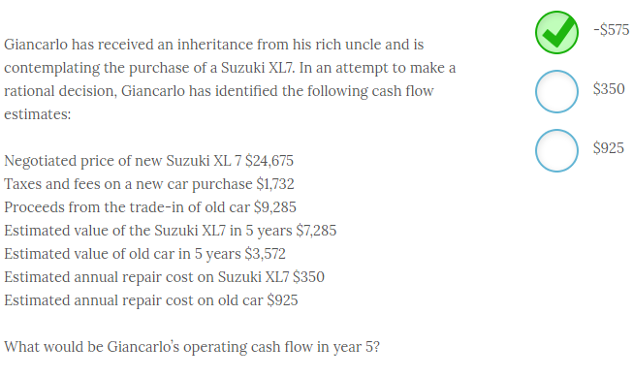

Giancarlo’s operating cash flow in year 5 would be **-$575**.

Giancarlo has received an inheritance from his rich uncle and is contemplating the purchase of a Suzuki XL7. In an attempt to make a rational decision, Giancarlo has identified the following cash flow estimates:

Negotiated price of new Suzuki XL 7 $24,675

Taxes and fees on a new car purchase $1,732

Proceeds from the trade-in of old car $9,285

Estimated value of the Suzuki XL7 in 5 years $7,285

Estimated value of old car in 5 years $3,572

Estimated annual repair cost on Suzuki XL7 $350

Estimated annual repair cost on old car $925

Giancarlo’s operating cash flow in year 5 would be -$575. To evaluate his operating cash flows from accepting the project you need to determine the incremental difference. In this case he would have spent $925 but instead spent $350. So his operating cash flows for buying the new car would be $350 - $925 = -$575. The formula is;

Replacement cash flows = cash flow for new asset – cash flow for the old asset.

Giancarlo probably should check and see if his insurance premium will go up or down. That would also be a relevant incremental cost if the premium differed. Any differences in fuel costs would also be relevant.

-------------------------------------------------------------------------------------------------------------------------------------------------------------------------------------------------------------

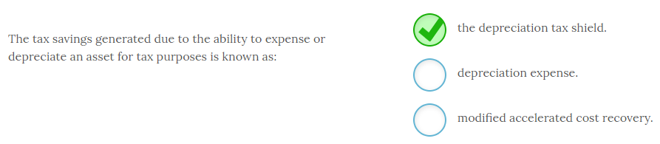

The tax savings generated due to the ability to expense or depreciate an asset for tax purposes is known as **the depreciation tax shield**. Being able to depreciate an asset reduces your tax liability and therefore is a relevant cash flow that is known as the depreciation tax shield. Depreciation expense is the actual amount you are allowed to expense in a given year for that asset. The modified accelerated cost recovery system (MACRS) is a legal IRS depreciation method that allows you to expense an asset more rapidly and therefore generate higher depreciation tax shields in the early years of a project.

MACRS depreciation helps you harness the time value of money by deducting larger amounts sooner. For this reason the choice of depreciation method does impact cash flows.

-------------------------------------------------------------------------------------------------------------------------------------------------------------------------------------------------------------

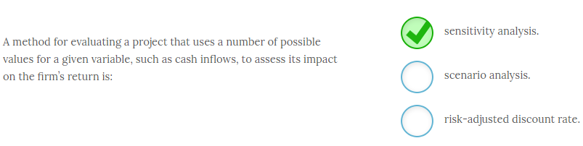

A method for evaluating a project that uses a number of possible values for a given variable, such as cash inflows, to assess its impact on the firm’s return is **sensitivity analysis**. In sensitivity analysis you identify a key variable that has a significant impact on profits and do some “what if” analysis by changing the value of that one variable and seeing how sensitive profits are to that change. This type of analysis allows you to determine the threshold values where the project becomes unprofitable.

For example, if you make cattle feed you might see how sensitive profits are to fluctuations in the price of corn. In scenario analysis you look at changing several variables at one time. This may often result in a “best case” and “worst case” set of scenarios so you can evaluate profitability in a poor economy, a booming economy, or some other scenario.

Risk-adjusted discount rates are sometimes used to adjust for a perceived difference in risk associated with a project’s cash flows. Higher risk projects will be evaluated with a higher discount rate to ensure that the project’s return is sufficient to compensate for the higher risk.

-------------------------------------------------------------------------------------------------------------------------------------------------------------------------------------------------------------

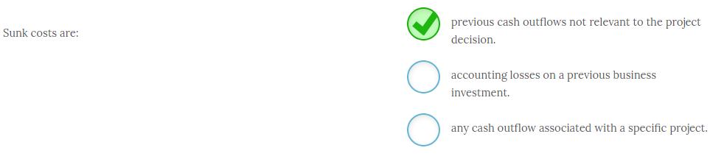

Sunk costs are **previous cash outflows not relevant to the project decision**. At times a firm may do a pilot program, a test market, or incur some other cost that either aided product development or helped provide additional information about a specific project. These expenses have already been incurred, and from an accounting perspective may be assigned to this project, but they are not relevant to the financial analysis of whether to accept or reject this project. Incorrectly including these sunk costs can lead you to reject a good project.

Accounting losses are therefore not relevant to the financial analysis and only those cash outflows that have already occurred are considered to be sunk costs. There are numerous cash outflows that are relevant and should be considered.

Some projects may be on the margin in terms of being accepted. For these projects including sunk costs can cause you to reject them and cost the firm money. Think about the cash flows and evaluate them on the incremental basis. If I accept this project will this cash flow occur? If so, it is relevant.

-------------------------------------------------------------------------------------------------------------------------------------------------------------------------------------------------------------

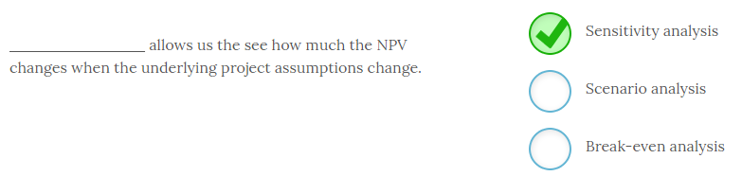

**Sensitivity analysis** allows us the see how much the NPV changes when the underlying project assumptions change. For example, we may be concerned that our sales forecast is too high. We can plug in different sales numbers and see how NPV changes to give us a better understanding of how sensitive the NPV is to reduced sales. This additional information can give us a greater level of confidence about the project, or cause us to rethink our forecasts.

Scenario analysis is similar but you change multiple parameters to determine the impact on NPV. We may change costs, sales revenues, pricing strategies or numerous other factors and see how it affects the NPV. Break-even analysis is used to determine the minimum sales needed for NPV to equal zero.

-------------------------------------------------------------------------------------------------------------------------------------------------------------------------------------------------------------

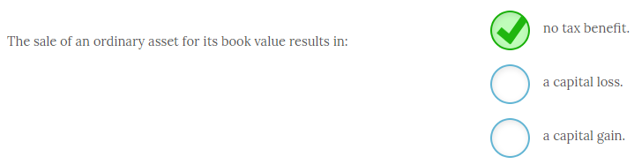

The sale of an ordinary asset for its book value results in **no tax benefit**. There is no tax impact of any kind when an asset is sold for its book value. If an asset is sold for more than its book value the firm will have a capital gain known as recaptured depreciation and it will have to pay taxes on that gain. If the firm sells the asset for less than its book value it will have a capital loss that may be used to offset other gains.

Firms often dispose of assets for something other than book value and the tax consequences of this are a relevant cash flow for a replacement project.

-------------------------------------------------------------------------------------------------------------------------------------------------------------------------------------------------------------

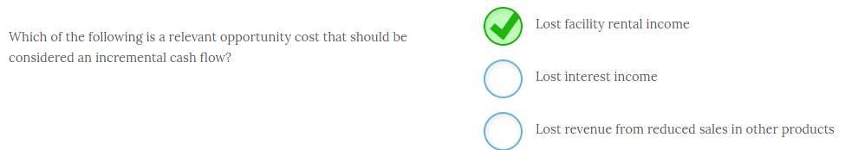

**Lost facility rental income** is a relevant opportunity cost that should be considered an incremental cash flow. This is due to the fact that you are now using a facility for your new project that could be rented out to someone else. Since this resource has a valuable alternative use you need to factor that lost income in as a relevant cash flow.

Lost interest income is factored into the discount rate and is not an opportunity cost even though you are no longer receiving the interest. Lost revenue from reduced sales in other products is a relevant incremental cost that is considered a product externality that is often dubbed cannibalization. However, it is not an opportunity cost.

Any property that could generate revenue via sale or rental results in an opportunity cost to the current project and it must be considered a relevant cash flow.

-------------------------------------------------------------------------------------------------------------------------------------------------------------------------------------------------------------

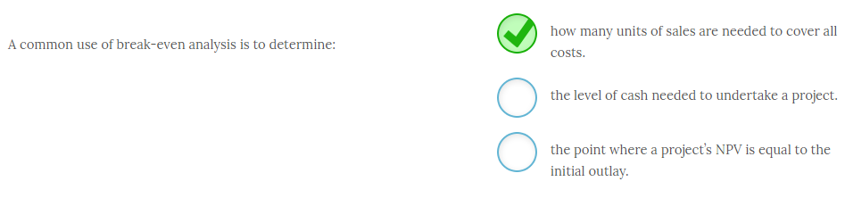

A common use of break-even analysis is to determine **how many units of sales are needed to cover all costs.** Break-even analysis can be adapted to look at a number of variables but it is commonly used to identify the exact number of units that will have to be sold in order to cover all the project’s costs. Once that number is identified then the financial manager can meet with the sales force to determine whether this sales level is possible. That response can either reinforce a good project or cause management to rethink their assumptions and potentially reject the project.

The level of cash needed to start a project will be determined independent of any break-even analysis but it will become one of the inputs. And, the point where the present value of the project’s cash flows is equal to the initial outlay is the point where the project’s NPV is equal to zero. The level of sales, either in terms of revenue or units, where the NPV is equal to zero is the break-even point.

-------------------------------------------------------------------------------------------------------------------------------------------------------------------------------------------------------------

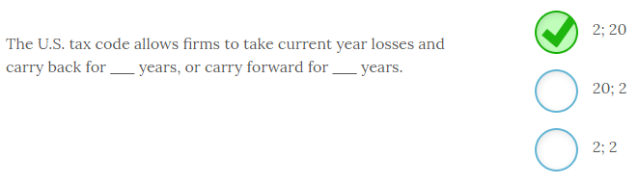

The U.S. tax code allows firms to take current year losses and carry back for **2** years, or carry forward for **20** years. In other words a firm can take current year losses and use those to offset gains in the previous two years or offset gains in the next 20 years. This provision enables firms to minimize their tax liability and is treated as a cash inflow.

-------------------------------------------------------------------------------------------------------------------------------------------------------------------------------------------------------------

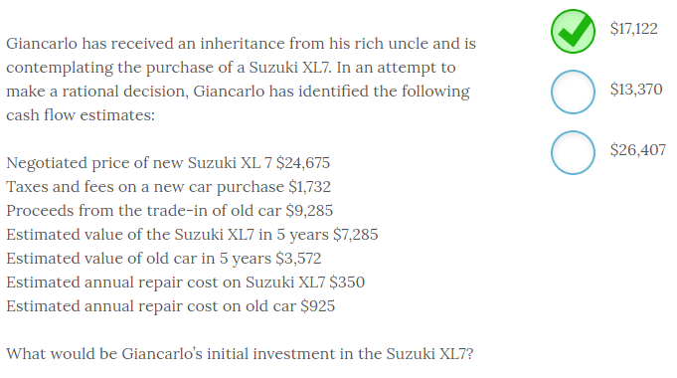

Giancarlo has received an inheritance from his rich uncle and is contemplating the purchase of a Suzuki XL7. In an attempt to make a rational decision, Giancarlo has identified the following cash flow estimates:

Negotiated price of new Suzuki XL 7 $24,675

Taxes and fees on a new car purchase $1,732

Proceeds from the trade-in of old car $9,285

Estimated value of the Suzuki XL7 in 5 years $7,285

Estimated value of old car in 5 years $3,572

Estimated annual repair cost on Suzuki XL7 $350

Estimated annual repair cost on old car $925

Giancarlo’s initial investment in the Suzuki XL7 will be **$17,122**. To arrive at this number you have to include the total out-of-pocket costs for the car and deduct any trade-in value so you can evaluate only incremental cash flows. So, the initial investment = $24,675 + $1,732 - $9,285 = $17,122. If Giancarlo decides to buy this car this will be the amount he will need to complete the transaction.

This process involves the same steps you would make to evaluate any equipment replacement decision. Are there taxes, installation charges, shipping fees, demolition expenses, or any other relevant cash flows? Always think in terms of total incremental cash inflows and outflows associated with a project.

-------------------------------------------------------------------------------------------------------------------------------------------------------------------------------------------------------------

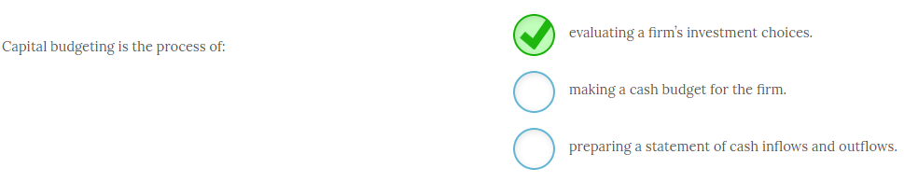

Capital budgeting is the process of **evaluating a firm’s investment choices**. Viable firms constantly seek out ways to invest funds in order to increase shareholder wealth. After potential investment options are identified they need to be evaluated. Capital budgeting is the process of identifying and evaluating these options and then investing in the ones that will increase shareholder wealth.

Making cash budgets for the firm and preparing a statement of cash flows are also critical activities for the firm but are not considered to be capital budgeting.

Note that capital budgeting will involve identifying project-specific cash inflows and outflows in order to evaluate the project using NPV, IRR, payback or any other evaluation tool.

-------------------------------------------------------------------------------------------------------------------------------------------------------------------------------------------------------------

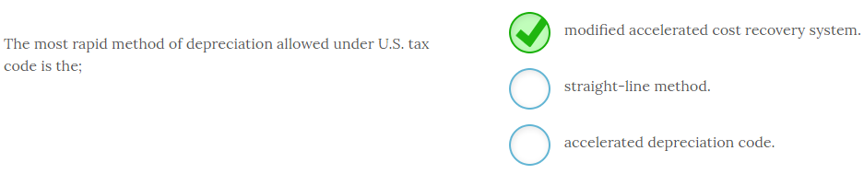

The most rapid method of depreciation allowed under U.S. tax code is the **modified accelerated cost recovery system**, or MACRS. From a financial standpoint it is in the firm’s best interest to expense any assets acquired in the fastest manner. MACRS is the method that will depreciate assets the quickest. Assets are categorized according to an IRS recovery period schedule and then the fraction of the value of the asset that can be depreciated each year is determined from the IRS MACRS table.

Straight line depreciation is much slower and the accelerated depreciation code is a fictional construct.

-------------------------------------------------------------------------------------------------------------------------------------------------------------------------------------------------------------

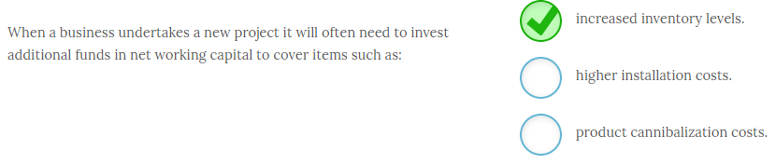

When a business undertakes a new project it will often need to invest additional funds in net working capital to cover items such as **increased inventory levels**. Changes in net working capital are easy to forget about but any increased level of business typically requires additional investment in inventory, accounts receivables, and other current asset accounts. While a portion of this will be funded through a natural increase in liabilities in most cases this will not fund the entire increase in current assets.

Installation costs are typically included in the initial outlay and the impact of product cannibalization should be netted out of sales.

Most of the time when you increase sales you will need additional funds in inventory and accounts receivable if you have credit sales. Knowing that amount on the front end lets you properly evaluate the project and plan for those needs if the project is accepted.

-------------------------------------------------------------------------------------------------------------------------------------------------------------------------------------------------------------

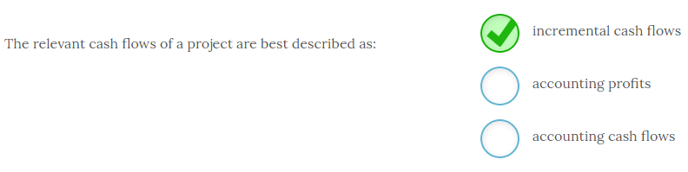

The relevant cash flows of a project are best described as **incremental cash flows**.

For financial decision-making, the only relevant cash flows are the marginal or incremental cash flows. These include any costs that you would not incur unless you undertake the project and only the addition to current revenues that you would receive if you accepted the project. Accounting cash flows are the starting point to help you identify relevant cash flows but then you will make adjustments for expenses that are non-cash outlays. Since accounting profits are also impacted by numerous non-incremental cash flows, they can only serve as a starting point to identify relevant incremental cash flows.

One example of an incremental cash flow that would differ from accounting numbers is the reduction in revenue that might occur if you introduced a new product that cannibalized your current offerings. Using only accounting data and focusing solely on the project’s cash flows, and not on the impact that accepting this project would have on the cash flows of other divisions, could lead you to make a poor decision. However, that impact is a relevant incremental cash flow from a finance perspective.

-------------------------------------------------------------------------------------------------------------------------------------------------------------------------------------------------------------

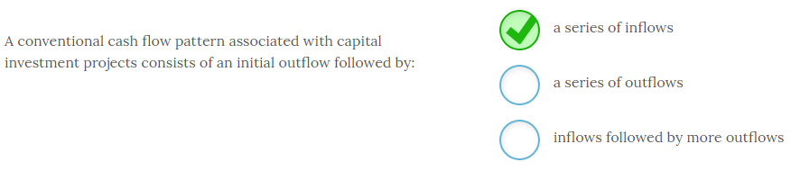

A conventional cash flow pattern associated with capital investment projects consists of an initial outflow followed by **a series of inflows**.

In most cases, a firm will make an initial investment that will then begin generating cash inflows for the firm. This is the conventional cash flow pattern.

However, the firm may be evaluating a project that will require an initial outflow followed by a series of outflows. A piece of pollution control equipment would fall under this category. For these projects, you are looking for the piece of equipment that will accomplish your goals at the least cost.

Other projects may have some costs associated with termination that would require an additional outlay at the end of the project. A mining project that required land reclamation at the end would fall into this category.

Some projects may flip back and forth between inflows and outflows.

-------------------------------------------------------------------------------------------------------------------------------------------------------------------------------------------------------------

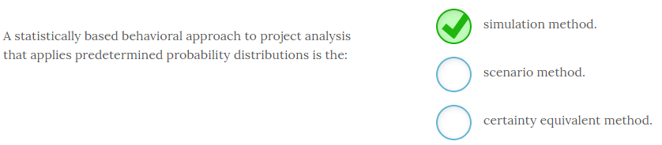

A statistically based behavioral approach to project analysis that applies predetermined probability distributions is the **simulation method**. A simulation approach sets ranges of values for critical inputs and then allows a computer to run thousands of iterations based on all variable combinations. One possible output is to see what percentage of the mathematical iterations results in a positive NPV. Using this method gives the financial manager a higher level of confidence and essentially provides a probability of success.

The scenario method is similar but you are typically only looking at a few scenarios such as a worst case, base case, and best case scenario. The certainty equivalent method reduces cash flows that occur further in the future and therefore lowers the project’s NPV to account for the higher risk associated with more distant cash flows.

Using a simulation analysis you might determine that 84% of the time this project generated a positive NPV. This is valuable piece of information about the project’s risk. However, keep in mind that you specified the ranges of the various inputs and the simulation is only as valuable as the parameters you provided for the program.

-------------------------------------------------------------------------------------------------------------------------------------------------------------------------------------------------------------

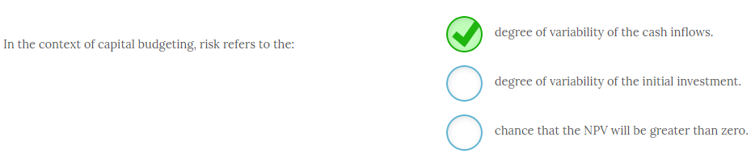

In the context of capital budgeting, risk refers to the **degree of variability of the cash inflows**. In finance risk is typically defined as the likelihood something will be different than we expect and in capital budgeting we make forecasts of the project’s cash flows that may or may not ultimately be accurate. While financial managers always attempt to base their forecasts on the best possible information they still do not have crystal balls and forecasting the future is challenging at best.

In general the amount of the initial investment is known with relative certainty so there is little risk in this known cash flow. And, if NPV is greater than zero that is a positive result and therefore not risk per se.

While risk may often be defined as variability what you are truly concerned with is downside variability. If something turns out better than expected that does not tend to bother us.

-------------------------------------------------------------------------------------------------------------------------------------------------------------------------------------------------------------

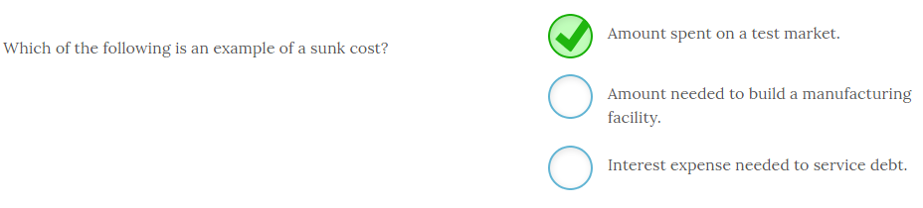

The **amount spent on a test market** is an example of a sunk cost. This money has already been spent and cannot be recovered. While this money will be attached to the project from an accounting perspective, as a relevant expense it should be excluded from the financial analysis of whether to undertake the project.

The other two cash flows have not occurred yet and are therefore not sunk costs. The capital expenditure needed is a relevant incremental cash flow. However, interest expense is not a sunk cost but it should also be excluded as a relevant cash flow since it is already factored into the discount rate used to compute the present value of the project’s expected cash flows.

-------------------------------------------------------------------------------------------------------------------------------------------------------------------------------------------------------------

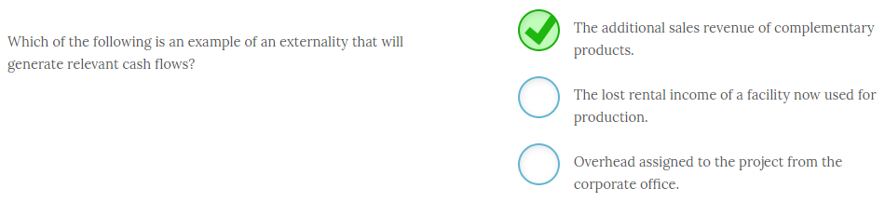

**The additional sales revenue of complementary products** is an example of an externality that will generate relevant cash flows. If you introduce a new product that stimulates the sales of an existing product then the increase in sales is an externality that is a relevant cash flow.

Any lost rental income is relevant but that is an opportunity cost and not an externality. Overhead should not be considered as a relevant incremental cash flow unless there is an increase in overhead costs that is directly related to the project and would not be incurred otherwise. While the CEO may spend a lot of time on the project they should not have any of their salary allocated as a project cost since the company would pay that anyway. This is an example of overhead costs that are not incremental so should therefore be ignored for financial decision making.

Perhaps a more common externality occurs when a new product erodes the sales of an existing product. This type of externality is known as cannibalism.

-------------------------------------------------------------------------------------------------------------------------------------------------------------------------------------------------------------

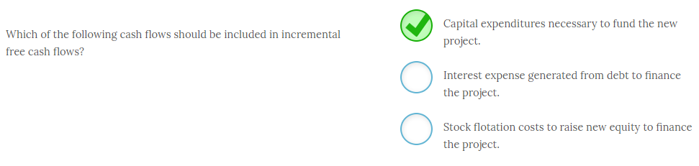

**Capital expenditures necessary to fund the new project** should be included in incremental free cash flows. While the accounting cost of new assets will be depreciated over the asset’s useful life the actual cash outlay to purchase the asset typically occurs on the front end of the project and is a relevant incremental cash flow.

Interest expense and stock flotation costs should not be included in incremental free cash flows since these costs are associated with how the project is financed and are therefore embedded in the discount rate used to evaluate the project.

While interest expense and flotation costs are actual incremental cash flows they should not be included in the analysis because it would double count their impact since the cost of capital used to discount project cash flows already incorporates these costs.

-------------------------------------------------------------------------------------------------------------------------------------------------------------------------------------------------------------

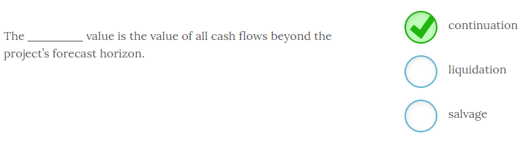

The **continuation**value is the value of all cash flows beyond the project’s forecast horizon. For example, a project life for evaluation purposes may be 8 years. However, many projects may continue to generate cash flows beyond that 8 year period. To account for those additional cash flows you will determine a continuation value, or terminal value, which is a lump sum amount that you will use for a final cash flow for all cash flows that occur beyond the forecast horizon.

A liquidation value, or salvage value, is the value of all assets sold at the project’s end.  Sometimes this value will be negative if there are disposal fees or reclamation costs.

-------------------------------------------------------------------------------------------------------------------------------------------------------------------------------------------------------------

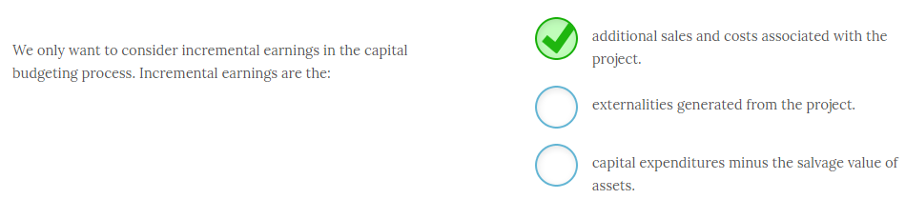

We only want to consider incremental earnings in the capital budgeting process. Incremental earnings are the **additional sales and costs associated with the project**. Incremental earnings will be the incremental revenues minus the incremental expenses, or any change in net earnings that occurs as a result of accepting the project.

Externalities include any change in cash flows from other projects that occur as a result of undertaking a specific project. These can include cannibalization of other product sales, or synergies that might arise from undertaking a particular project.

Capital expenditures are typically a component of the initial investment but might also be needed over the life of a project at specific points in time.

Learn to think incrementally and ask yourself this question; Would this cash flow occur if I did not undertake this project? If it will occur anyway it is not an incremental cash flow and therefore not relevant.

-------------------------------------------------------------------------------------------------------------------------------------------------------------------------------------------------------------

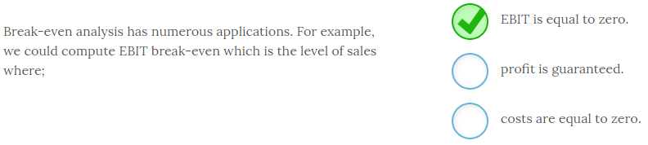

Break-even analysis has numerous applications. For example, we could compute EBIT break-even which is the level of sales where **EBIT is equal to zero**. However, while this method helps us understand the level of sales needed to break even from operations it does not factor in the up front costs of the project. The NPV break-even is a better tool that incorporates all the project’s cash flows.

-------------------------------------------------------------------------------------------------------------------------------------------------------------------------------------------------------------

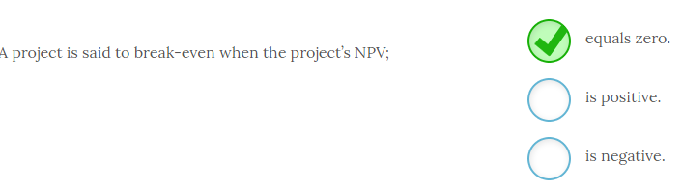

A project is said to break-even when the project’s NPV **equals zero**. When the NPV is equal to zero that means the project’s return is expected to be exactly the cost of capital. That’s why we accept any project with an NPV of zero or higher. Negative NPVs indicate the project will not make the required return which is the firm’s cost of capital.

-------------------------------------------------------------------------------------------------------------------------------------------------------------------------------------------------------------

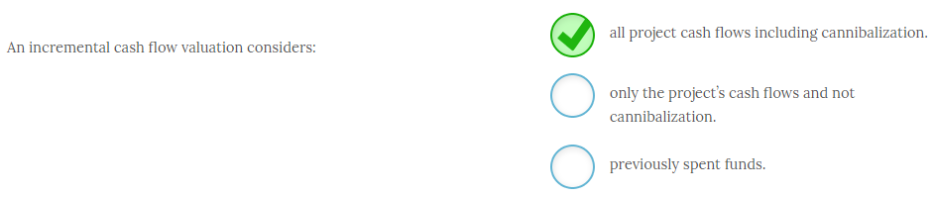

An incremental cash flow valuation considers **all** **project cash flows including cannibalization**. The only relevant cash flows are the ones that you would not realize or would not be incurred unless you undertake a particular project. If you are considering undertaking a project that will generate sales that will reduce your sales in other products (cannibalize them) then that is a relevant cash flow. If your new product is expected to sell $5 million in the first year but it will reduce your other sales by $1 million then the relevant cash flow is the $4 million increase in sales. You should always include the impact of cannibalization of existing sales as an incremental cash flow.

Conversely previously spent funds, or sunk costs, cannot be recovered and should not be considered as a relevant cash flow. Including them can lead to an incorrect reject decision of an investment that may have allowed you to recover a portion of those costs instead of losing all of them.

Some products may create synergies with existing products and generate an additional relevant cash inflow. If you can quantify these they should also be included in the incremental analysis.

-------------------------------------------------------------------------------------------------------------------------------------------------------------------------------------------------------------